
Group Assignment
CT077-3-2-DSTR
APD2F2506CS(CYB)
HAND OUT DATE : 4 DECEMBER 2025
HAND IN DATE : 9 FEBRUARY 2026
LECTURER : DR. MASRINA AKMAL BINTI SALLEH
GROUP NUMBER : Group 3

No. | Name | TP Number
1. | Foo Jia Shuen | TP076360
2. | Chew Kai Xuan | TP076457
3. | Kriti Chew Chia Shing | TP076886
4. | Fhang Ying Ying | TP076307

Workload Matrix
No | Name | Responsibilities
1 | Foo Jia Shuen | Coding Implementation: Linked List  - System Operations & User Interaction  - Seating chart display  - Seat occupancy checking  - Input validation  - User interaction and menu integration  Documentation: Linked List  - 3.0 Input Output Screenshot  - 3.2.1 Load From File  - 3.2.2 Add Passenger  - 3.2.3 Delete Passenger  - 3.2.4 Manifest Report  - 3.2.5 Seating Chart  - 3.2.6 Search by Row  - 3.2.7 Search by Class  - 3.2.8 Binary Search by Passenger ID  - 4.0 Summary Discussion  - 4.2 Linked List –Based Implementation  - 5.4 Reflection
2 | Chew Kai Xuan | Coding Implementation: Array  - Reservation  - Cancellation  Documentation: Array  - Introduction  - 2.1.1 Definition  - 2.1.2 Data Containers and Operations  - 2.1.3 Data Structure Implemented  - 2.1.4 Sorting Algorithms Implemented  - 3.0 Input Output Screenshots  - 3.1.1 Reservation  - 3.1.2 Cancellation  - 4.1 Array-based Implementation  - 5.4 Reflection
3 | Kriti Chew Chia Shing | Coding Implementation: Linked List  - Linked list structure and node management  - Insertion operations  - Deletion by passenger ID  - Linked list reversal  - Merge sort implementation  - Searching algorithms  Documentation: Linked List  - 2.2 Linked List  - 2.2.1 Definition  - 2.2.2 Data Container and Operations  - 2.2.3 Linked List Algorithms Implementations  - 4.3 Array vs Linked List  - 5.4 Reflection
4 | Fhang Ying Ying | Coding Implementation: Array  - Passenger Manifest & Reports  - Seat Occupancy  Documentation: Array  - 2.1.2 Data Containers and Operations  - 2.1.3 Data Structure Implemented  - 2.1.4 Sorting Algorithms Implemented  - 3.0 Input Output Screenshots  - 3.1.3 Manifest and Seat Report  - 3.1.4 Seating Grid & Seat Lookup  - 4.1 Array-based Implementation  - 5.4 Reflection

Table of Contents
Workload Matrix 2
1.0 Introduction 7
2.0 Theoretical Explanation 8
2.1 Array 8
2.1.1 Definition 8
2.1.2 Data Container and Operations 8
2.1.3 Data Structure Implemented 10
2.1.4 Searching Algorithms Implemented 14
2.1.5 Sorting Algorithms Implemented 24
2.2 Linked List 39
2.2.1 Definition 39
2.2.2 Data Container and Operations 39
2.2.3 Linked List Algorithms Implemented 40
3.0 Input-Output Screenshots 58
3.1 Array 58
3.1.1 Reservation 58
3.1.2 Cancellation 61
3.1.3 Manifest and Seat Report 64
3.1.4 Seating Grid & Seat Lookup 81
3.2 Linked list 87
3.2.1 Load From File 87
3.2.2 Add Passenger 88
3.2.3 Delete Passenger 90
3.2.4 Manifest Report 91
3.2.5 Seating Chart 93
3.2.6 Search by Row 95
3.2.7 Search by Class 98
3.2.8 Binary Search by Passenger ID 100
4.0 Summary Discussions 101
4.1 Array-Based Implementation 101
4.2 Linked List-Based Implementation 105
4.3 Array vs Linked List 109
5.0 Conclusion and Reflection 114
5.1 Advantages of the System 114
5.2 Disadvantages of the System 114
5.3 Recommendations 115
5.4 Reflection 119
6.0 References 121

1.0 Introduction
The efficiency and reliability are very important for an airline company. The Flight Reservation and Seating Management System represents a critical component that bridges passenger service demands with operational efficiency requirements. This assignment is going to design a Flight Reservation and Seating Management System, using two different data structure which is array and linked list with several type of search algorithms and sort algorithms. In this documentation is going to explain the definition of both data structure, search algorithms, sort algorithms, implementation and the input and output. Besides, the difference between the system that build by array or linked list will be compare by using time usage and space usage.

2.0 Theoretical Explanation

2.1 Array

2.1.1 Definition
Array is a data structure that store the collection of fixed number of elements, and all the elements are using the same data type inside it. It is suitable for storing and processing ordered data such as lists of numbers, records, or objects. This is because it allows fast and direct access to elements. However, array has a fixed size once it created which means the number of elements it can hold has a limit unless additional memory management is performed.

2.1.2 Data Container and Operations
In this flight reservation system, one-dimensional (1D) dynamic array is applied as the primary data container storing all passenger reservation records. The elements in the array represent as pointers to the passengers within the reservation system. With the application of dynamic array instead of static approach, arrays of inconsistent size can be handled effectively. It is a more practical implementation for this flight reservation system where the reservation records fluctuate frequently due to new reservations and cancellations.
Every element consists of a reference to a passenger record, which includes the attributes Passenger ID, Passenger Name, Seat Row, Seat Column, Flight Class, and Flight ID. With array indexes, records of the passengers can be accessed, allowing timely and direct retrieval of passenger details from the excessive number of records.
The system supports the operations including:
Insertion (Reservation)
When a flight reservation for a passenger is made, the new record is inserted into the next available index of the array, where the count of the passengers increases accordingly.

Deletion (Cancellation)
When a flight reservation for a passenger is being cancelled, the target passenger is located through searching their passenger ID. When the reservation record is cancelled, it is removed from the array as all the following elements shift left by one index to maintain the continuity of the array.

Traversal (Manifest & Report)
Aside from a full general report, this operation supports filtering and sorting reservation records according to selected attributes using searching and sorting algorithms, where the array is traversed sequentially to display passenger manifests and flight reservation reports.

Search (Seat Lookup)
Searching algorithms including linear and binary searches are implemented in this operation in order to display the seating report for specific flight, and passengers’ details of the target flight.

2.1.3 Data Structure Implemented
1D Array
1D Array known as One-Dimensional Array. It is a linear data structure that stores elements in continuous memory locations and access using single index. 1D Array has a fixed-size collection of homogeneous elements arranged sequentially in memory, where each element can be directly accessed using its position (index) ranging from 0 to n-1. The fundamental characteristics of 1D arrays include their static memory allocation during compilation, random access capability through indexing, and efficient traversal operations. In this Flight Reservation System, using 1D array for passenger management enable fast retrieval operations essential for frequent passenger lookups during check-in and boarding processes.
Justification
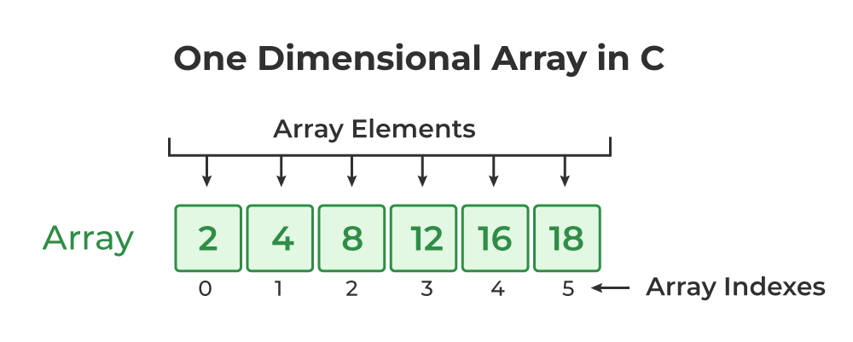Figure 1: 1D Array
Implementation
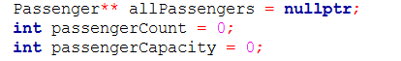
As illustrated in the figure above, each element within the array holds a pointer to a Passenger object instead of the actual object.
allPassengers: Array that stores the pointers to independent passenger objects
passengerCount: Variable keeping track of the number of active passengers stored within
PassengerCapacity: Variable containing the existing maximum size of the array, which allows controlled memory allocation and expansion of the ‘allPassenger’ array in the future

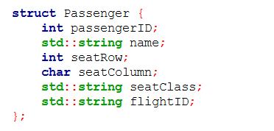
Figure 2: Passenger
A one-dimensional array is implemented in order to store the passenger’s reservation records in a sequence, where each element within the array represents a record and followed by the next passenger record after the previous one as they are loaded.

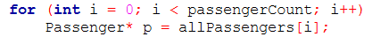
Figure 3: 1D Array Implementation in Reservation
The figure above illustrates how the 1D array for allPassengers is traversed sequentially through a for-loop. Each record of the passengers is accessed with a single index, which in this case are represented by the variable ‘i’. This method was implemented in searching, sorting, and displaying reservation information of the passengers.

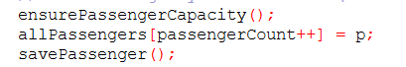
Figure 4: Dynamic Array Helpers (Functions)
The figure above illustrates how one-dimensional array was implemented in the reservation process, within the source code file, ‘addArray.cpp.’
ensurePassengerCapacity: The system verifies if the array contains enough space for an addition of the pointer to a passenger object before a reservation.
allPassengers[passengerCount++] = p: The passenger is stored at the next available position, while the total number of passengers increase simultaneously, allowing addition of new passengers safely.

Dynamic Array Management (Resizable Array)
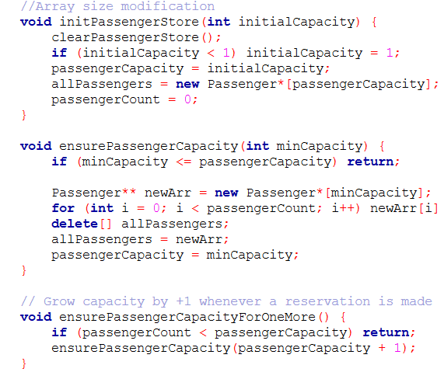
Figure 5: Dynamic Array Helpers (Coding)
As arrays are fixed in size when they are initialized at the beginning, this results in the possibility of overflowing the array when the number of passengers exit the size limit of the array. By implementing dynamic array, unlimited elements can be placed within it.
As the system should remain within the scope through avoiding implementing STL containers, the passenger records array is resized everytime it is full in order to allow unlimited reservations. An array with a new size is initialized before all the existing passenger records are duplicated into it, while the current array is dropped from the memory to assure memory usage efficiency.

Manipulation of 1D Array
- Reservation: addPassenger()
Figure 6: 1D Array Manipulation (Reservation)
Passenger reservation is applied in the system through inserting the new record of the passenger at the next index that is available within the one-dimensional array. After the insertion, the passenger count is increased in order to reflect the array with the new updated size.

- Cancellation: delPassenger()
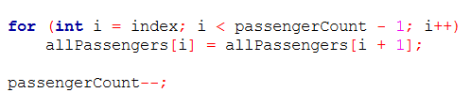
Figure 7: 1D Array Manipulation (Cancellation)
Passenger cancellation is executed through first locating the target passenger to be removed in the array, before shifting all the passenger elements one position to the left to ensure the array remains contiguous.

2.1.4 Searching Algorithms Implemented
The system has implemented both binary and linear searching algorithm.
Binary Search
Definition
Binary search is an efficient searching algorithm; it will separate the sorted dataset into two halves repeatedly to locate the target element. This algorithm will compare the target value with the middle element in each step to eliminate half of the remaining search space.
Advantages
- Binary search is extremely high efficiency because it has a time complexity of O(log n). This reason makes it significantly faster than linear search for large datasets.

- Binary search is suitable for large passenger records because it has good scalability, which makes the performance remain efficient as the dataset size increases.

- The performance of binary search is predictable. The number of comparisons is consistently low, ensuring stable execution time.

- Binary search is suitable for indexed data. When data is sorted by key attributes such as passenger ID, seat row, or column, binary search performs optimally.
Justification for Use in This System
Binary search is implemented to demonstrate efficient search operations on sorted passenger data. By sorting the data beforehand, the system can retrieve records such as passenger ID, seat position, or class rapidly. This allows meaningful comparison against linear search and highlights the performance benefits of preprocessing through sorting.

Linear Search
Definition
Linear search is a simple searching solution where elements of the data structure are examined in a sequential manner until the target is allocated or the end of the data container is reached. It is much simpler to apply as it requires no preprocesses or requirements of the type of data to be handled like binary search does.
Advantages
- No preprocessing required as the algorithm supports both sorted and unsorted data.

- More ideal for simple searching operations as its logic is direct.

- Consumes lesser auxiliary memory than binary search due to consistency in use of extra memory.

- Effective and preferrable on small datasets to avoid overhead.
Justification for Use in This System
Linear search is implemented to allow direct searching on unsorted passenger data and to serve as a baseline for performance comparison. It is particularly useful when immediate search results are required without the cost of sorting, such as scanning seat occupancy or performing one-off searches.

Example
Binary Search
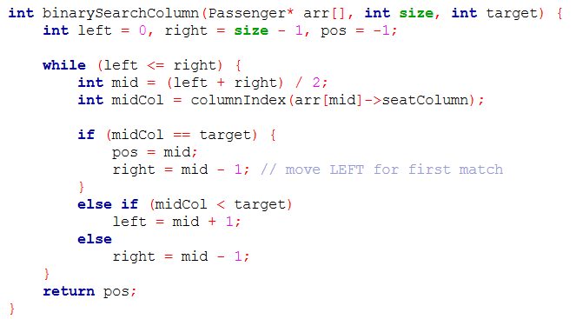
Figure 8: Binary Search Column
Binary search is implemented in filtered reports and seat lookup. It filters the reservation report and seat grid for each flight ID based on a specific supported attribute for searching, including seat column, seat row, seat index, flight class, passenger name, passenger ID, and flight ID. As binary search only works on sorted arrays, the arrays are copied into a temporary array before the search begins. The temporary array stores the passenger records in a sorted format where the sorting is based on the attribute to be filtered with.
The parameters for this function are the passenger records array, the size of the array (number of reservations), and the value to be searched for from the array. The start and end indexes of the search range are defined, while the variable ‘pos’ contains the index of the target value.
The while loop is the core component of binary searches, which repeats until there are no ranges left to search. Within each loop, the middle index of the current range being searched is calculated to get the value held at the current index. If the value matches the target, then its index is stored into the ‘pos’ variable. Then the range is moved to left by one index to find the first occurrence, which ensures the earliest matching record can be identified.
Though if the median of the search range is smaller than the targeted value, the right half of the range is examined. The same logic applies to if the median of the range is larger.
After the binary search, the index of the first matching passenger record is returned. As arrays used in binary search are sorted, matching records forward from the first matching record are retrieved and returned to ensure all matching records are retrieved.
Linear Search
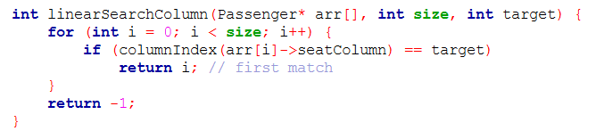
Figure 9: Linear Search Column
The same parameters are passed into the function to perform a linear search by seat column. The loop designed in linear search performs a scan on all the elements starting from the beginning of the array to the end or until a target is found, checking in a sequential manner. If the target value is found from the array, the position of the first match is returned. The function returns ‘-1’ to indicate no matching record was found from the array if no match was found.
Once the first matching record is found, the program scans forward from there in order to acquire passenger records with the specific matching attribute.

Other Areas Implemented
Filtered Report by Row | 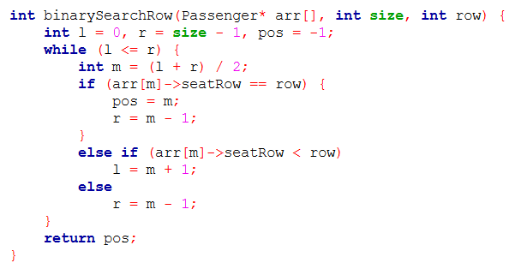  Figure 10: Filtered Report by Row (Binary Search)
Filtered Report by Row | 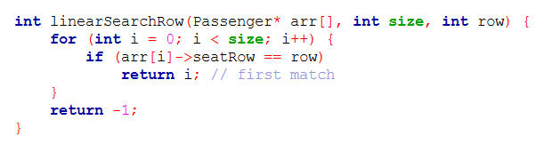  Figure 11: Filtered Report by Row (Linear Search)
Filtered Report by Seat Index | 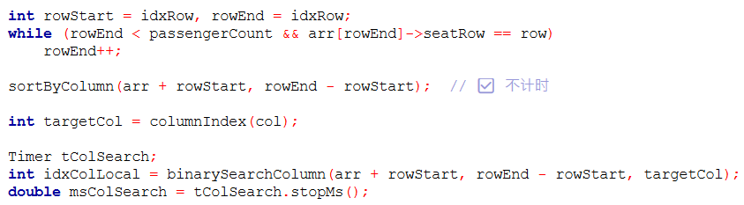  Figure 12: Sort by Seat Index - Row  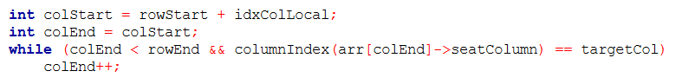  Figure 13: Sort by Seat Index - Column
Filtered Report by Seat Index | 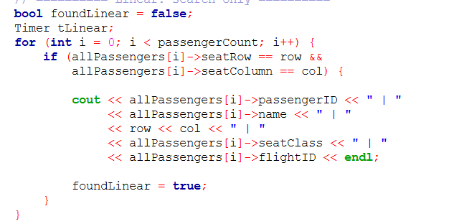  Figure 14: Filtered Report by Seat Index (Linear)
Filtered Report by Class | 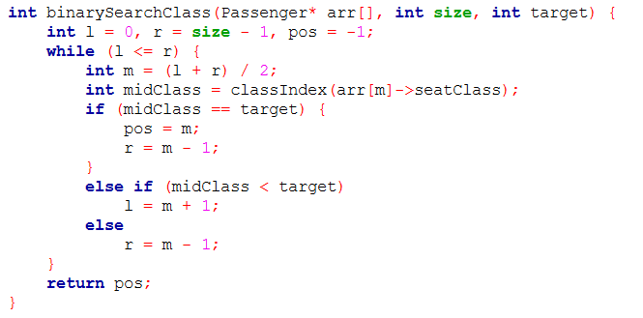  Figure 15: Filtered Report by Class (Binary Search)
Filtered Report by Class | 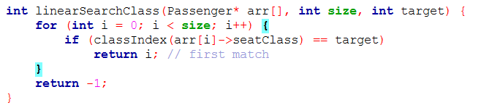  Figure 16: Filtered Report by Class (Linear Search)
Filtered Report by Name | 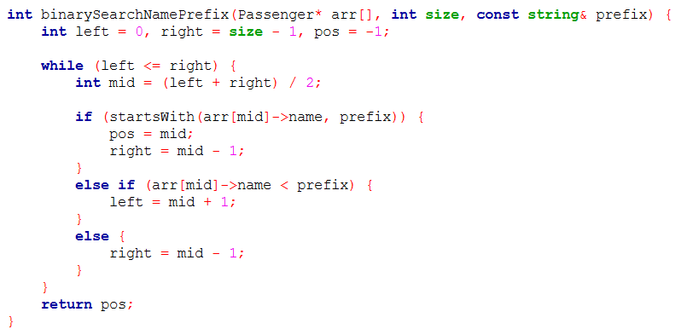  Figure 17: Filtered Report by Name (Binary Search)
Filtered Report by Name | 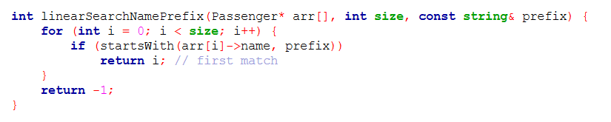  Figure 18: Filtered Report by Name (Linear Search)
Filtered Report by Passenger ID | 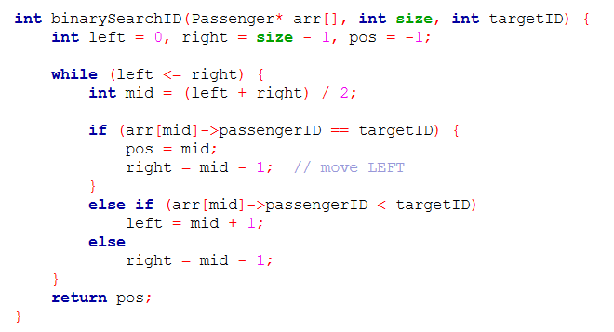  Figure 19: Filtered Report by Passenger ID (Binary Search)
Filtered Report by Passenger ID | 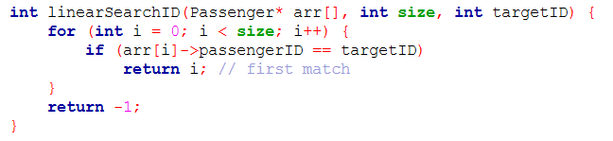  Figure 20: Filtered Report by Passenger ID (Linear Search)
Filtered Report by Flight ID | 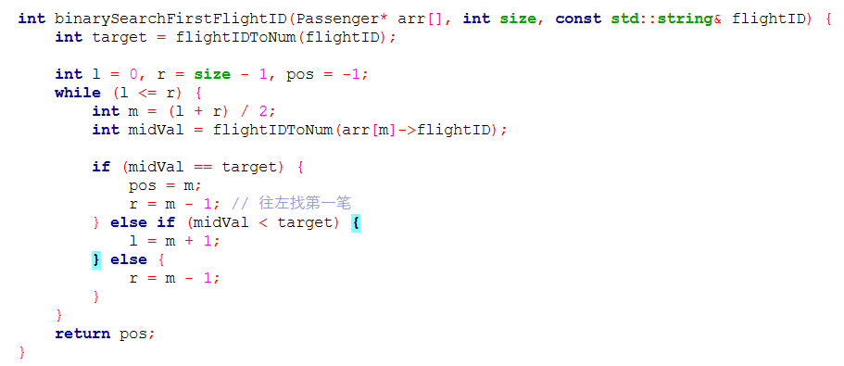  Figure 21: Filtered Report by Flight ID (Binary Search)
Filtered Report by Flight ID | 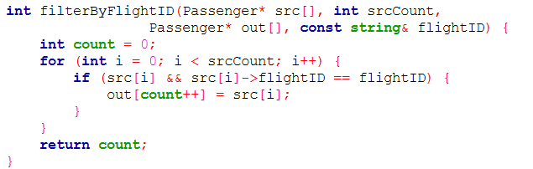  Figure 22: Filtered Report by Flight ID (Linear Search)
Generate New ID | 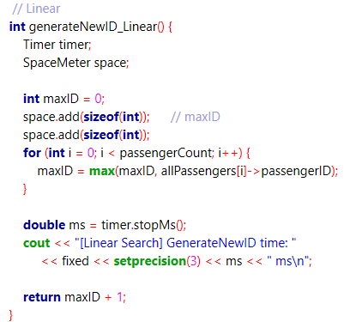  Figure 23: Generate New ID (Linear Search)
Generate New ID | 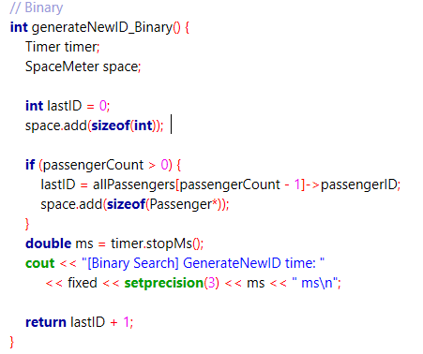  Figure 24: Generate New ID (Binary Search)
Check Seat | 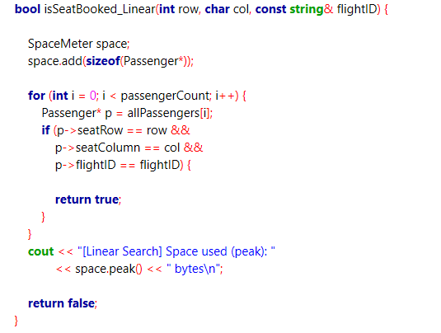  Figure 25: Check Seat (Linear Search)
Check Seat | 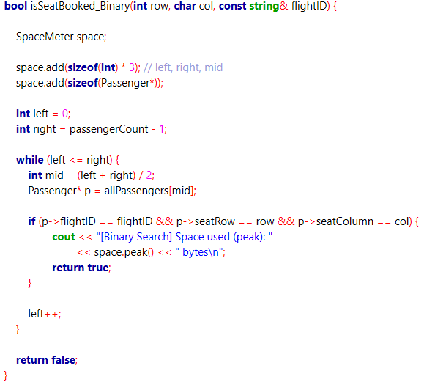  Figure 26: Check Seat (Binary Search)

Seat Lookup (Search by Flight ID) | 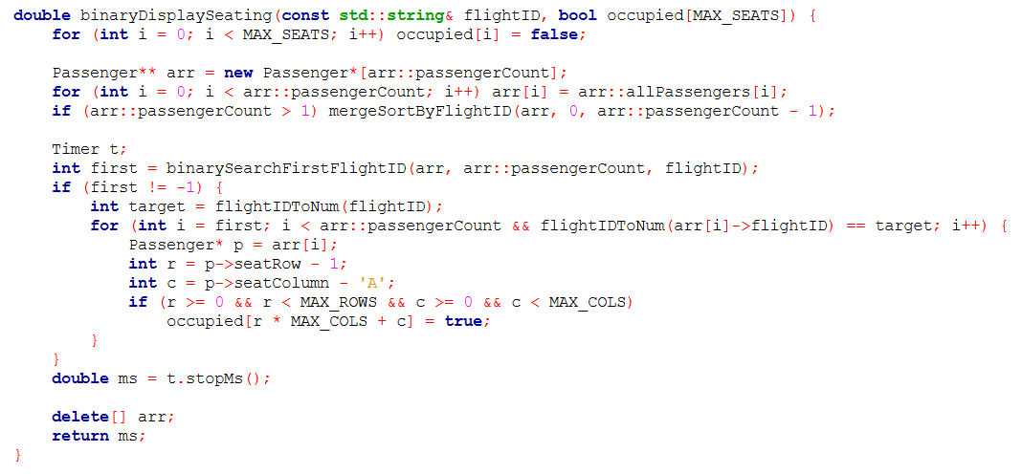  Figure 27: Seat Lookup (Binary Search)  All seats are initialized as unoccupied at the start. Then all the passenger records are copied into a temporary array to be sorted to prevent original data in the Passenger array unchanged. Then the passengers are being sorted by flight ID as binary search must be implemented on sorted arrays. Using the same binary search function, the first matching record is identified. The for-loop ensures that the boolean ‘occupied’ for all the passengers with the targeted flight ID are set to true to make the seats occupied.
Seat Lookup (Search by Flight ID) | 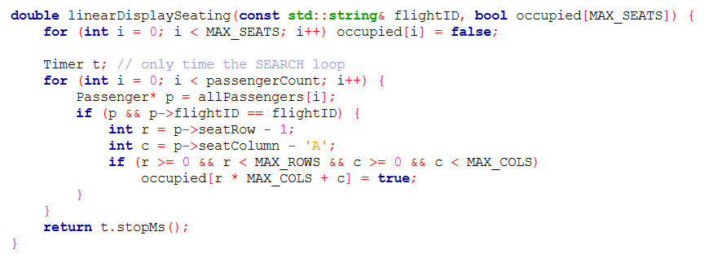  Figure 28: Seat Lookup (Linear Search)  Similar to binary search, the boolean is initialized as false at the start. After searching sequentially with linear search, the boolean for all the occupied seats are set to true.

2.1.5 Sorting Algorithms Implemented
Overview of Sorting Algorithms Implemented in the System
The report filtering operation has also implemented sorting algorithms as both linear and binary searching algorithms have been applied. In order to perform binary search, elements have to be sorted initially to ensure accuracy and reliability. Therefore, elements sorting has been executed preliminary to the searching operation.

Feature | Sorting Algorithm 1 | Sorting Algorithm 2
General Report | Radix Sort | Bubble Sort
Sort Report by Column  Filter Report by Column | Counting Sort | Bubble Sort
Sort Report by Row  Filter Report by Row | Counting Sort | Bubble Sort
Sort Report by Seat Index  Filter Report by Seat Index | Counting Sort (Row + Column) | Bubble Sort
Sort Report by Passenger Name  Filter Report by Passenger Name | Merge Sort | Bubble Sort
Sort Report by Flight Class  Filter Report by Flight Class | Counting Sort | Bubble Sort
Sort Report by Flight ID  Filter Report by Flight ID | Merge Sort | Bubble Sort
Seat Occupancy | Merge Sort | Bubble Sort

Counting Sort
Definition
A non-comparison-based algorithm for sorting elements through determining the number of occurrences of distinct values that are within a limited and consistent range. Instead of comparing elements with each other repeatedly, it locates the final position of elements according to the counts of their values. As it does not adopt comparison approaches, it executes at a significantly higher speed compared to other comparison-based algorithms.

Areas of Implementation
Counting sort is ideal when the values being handled are:
- Of numerical values and integers
- The range of possible values is small, and constant compared to the number of elements
- Data distribution is known and bounded
In this flight reservation system, counting sort is implemented in:
- Sorting by seat columns: A to F
- Sorting by seat rows: 1 to 30
- Sorting by seat indexes: Rows + Columns
- Sorting by flight classes: Economy, Business, First

Practicality
Advantages
- High speed when handling key values of small ranges: No comparisons, runtime primarily depends on one-time scan on the input and processing small counting array
- Assured stability: Records of the same key value are in the original order even after sorting, preserving the order logic
- Deterministic performance: Time complexity is consistent, regardless of the initial order of the elements in the dataset

Limitations
- Impractical for key with large ranges, arbitrary strings, and values containing floating-points
- Range of key values has direct influence on the auxiliary memory required for the sorting process

Justification: Practicality in the System
Counting sort is more effective in this reservation system as certain attributes supporting sorting and filtering are of small and constant ranges. These characteristics fulfil the requirements of Counting Sort.
In this system, counting sort is being used to sort passenger records according to seat columns, seat rows, and flight classes. These attributes have limited ranges, enabling this algorithm to sort data in linear time without the requirement for additional time for comparisons.
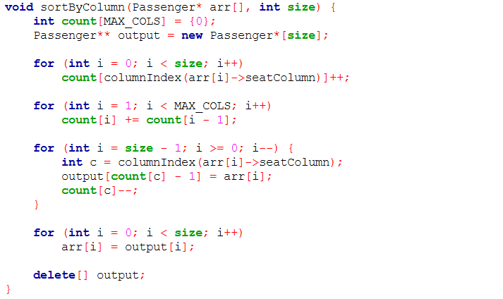
Figure 29: Sort by Column (Counting sort)
Counting sort is being implemented in sorted report and filtered report involving seat index, seat column, seat row, and flight class. Similarly, this sorting algorithm was implemented in binary searching involving those attributes. These attributes have small ranges, which makes counting sort an ideal algorithm compared to other algorithms that are comparison-based.
For each feature supporting counting sort, a key from the Passenger array is selected as the basis for the sorting process, such as:
Sorted Report by Seat Column: Using seat column as the key
Sorted Report by Seat Row: Using seat row as the key
Sorted Report by Seat Index: Using seat index as the key
Sorted Report by Flight Class: Using flight classes as the key
The key values are then converted into smaller integer index in order to be used with a counting array, ‘count[].’ The size of the array is parallel to the number of possible key values, and the elements within the array are initially initialized as zero.
Through implementing counting sort algorithm, the function executes a for-loop to scan through the passenger records once to identify the number of occurrences for each key value. Then the counting array is converted into a cumulative array, where each position represents the ending index of the group for the key in the sorted array.
A temporary array is created to store the newly organized array sorted based on the selected key. Through a right to left traversal, the stability for the passenger array is assured, where the passenger is being placed into the temporary array through cumulative count as the count decrements repeatedly until the count is zero.
The temporary array containing the sorted array is copied back into the original array holding passenger records and the temporary memory is released after the function.

Merge Sort
Definition
This sorting algorithm is a comparison-based solution that follows a divide-and-conquer approach to ensure efficiency and stability in data handling for arrays and lists. Elements are repeatedly being divided into two halves or known as subarrays. This process repeats until all subarrays only contain a single element. The elements of the subarrays are then compared with each other before being merged together with an ordered manner.

Areas of Implementation
Merge sort is often applied when:
- Size of the datasets is large
- Stability is emphasized
- External sorting
- When worst-case performance is predictable

In this system, this algorithm is applied in:
- Sorting by Passenger Name
- Sorting by Passenger ID
- Sorting by Flight ID

Practicality
Advantages
- Consistent performance: Consistent time complexity in all cases (Best, Average, Worst)
- Assured stability: Elements of the same key values keep the initial orders before sorting even after being executed with merge sort
- Predictable runtime: Data is always being divided into halves and merged back with a structured manner
- High efficiency when handling large datasets: The consistent time complexity allows this algorithm to remain practical and efficient even when the size of the datasets is large
- Ideal for multi-key sorting: Multiple sorting passes can be implemented without affecting the order sorted by other keys previously

Limitations
- Additional memory is required for placement of extra resources required for the operation
- Notable overhead for small datasets
- Poorer performance compared to counting and radix sort when the range of the key is small

Justification: Practicality in the System
The reason this algorithm was implemented in this airline reservation system is because the number of passenger records is not fixed and additional reservations may be made, making the size of the dataset inconsistent. So, consistent time complexity (O(n log n)) provides an assured efficiency in performance optimization.
Besides, passenger names and flight IDs are in strings format and arbitrary values, which is not supported by the counting sort approach. Apart from that, stability in the sorting process also ensures that passengers with the same keys are able to maintain the logically correct or initial order. Thus, the use of extra auxiliary memory is acceptable as dynamic array is implemented to store passenger data.

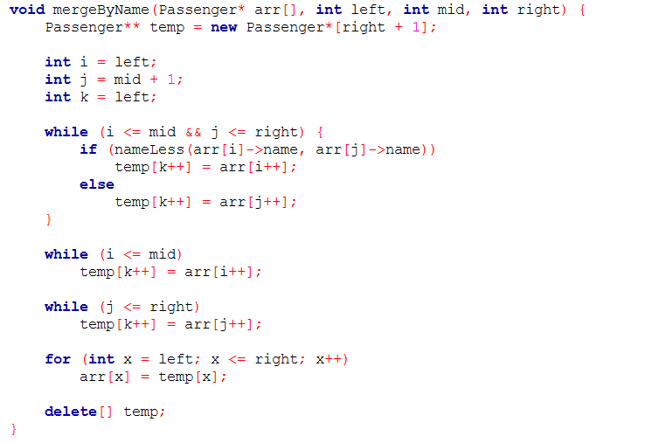
Figure 30: Merge by Name
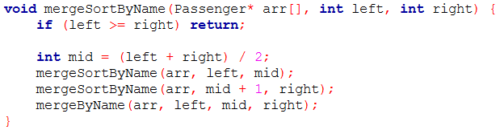
Figure 31: Merge sort by Name
Merge sort is implemented in the reservation process, and sorted report by name, passenger ID, and flight ID. The function mergeBy<Attribute Name> is responsible for merging two halves of the Passenger array that are already sorted. Aside from just sorting the report, this sorting algorithm was also implemented for binary searching in order to ensure that the array is sorted before searching.
The passenger array is being divided into two smaller subarrays repeatedly until each subarray only contains one element. Then two subarrays containing only one element are being merged back together. At this stage, the elements are being compared based on the attribute using to sort the report, which could be seat column, seat row, seat index, passenger name, passenger ID, class, or flight ID. The smaller array is then put into the temporary array to store sorted array.
Once the merging is finished, the sorted elements in the temporary array are then copied back into the original array containing passenger records to ensure that the original passenger details are being sorted gradually.
Similar merge sort structure and logic is being implemented to attributes supporting sorting in the system using exclusive comparison rules, including:
Sorted Report by Seat Index: Compare seat column lexicographically followed by seat row
Sorted Report by Seat Row: Compare seat row numbers numerically
Sorted Report by Passenger Name or by Seat Column: Compare alphabets within strings lexicographically
Sorted Report by Flight ID: Compare flight ID primarily before comparing class priority

Radix Sort
Definition
Radix sort algorithm is a non-comparative sorting algorithm. Numerical values are being sorted through processing their digits by one position at a time. Instead of direct comparison of the elements, records are being grouped according to their digit values (ones, tens, hundreds, and etc.). This technique is commonly applied with the use of a sub-sorting algorithm that has assured stability, such as counting sort.

Areas of Implementation
Radix sort is suggested for adoption when:
- Keys are integer-based
- When full dataset sorting is required where all records required sorting
- Length of the integer values is fixed and known
- Sorting large datasets
- Multi-key sorting is required

In this system, this algorithm is applied in:
- Sorting by Passenger ID (Only in General Report)

Practicality
Advantages
- Efficient when sorting keys with numerical values: This algorithm optimizes performance when dealing with numeric data with limited length
- Assured stability: Similarly, counting sort preserves the initial order of passengers with identical digit values
- Predictive and assured performance: Time complexity is not influenced by the unsorted data in the original datasets
- High efficiency with large datasets: Highly scalable, which is ideal for full manifest printing when passenger records may be altered in the future

Limitations
- Additional memory is required for counting sort and storage for temporary outputs
- Only suitable for specific data types and less practical for strings or values consisting of floating-points
- Potential inefficient space usage for smaller datasets

Justification: Practicality in the System
Radix sort is a practical solution in the system for general report as the report is sorted according to passenger IDs, which possess the trait of being numerical and with a fixed length. As the report requires processing of all existing passenger records, linear-like time complexity of this algorithm is more beneficial compared to other algorithms that are comparison-based.
Further than that, while radix sort requires more memory usage, this setback is acceptable in this context where performance and clarity is prioritized over effective space usage. On top of that, the memory is also released after the report is generated, making it a negligible limitation.

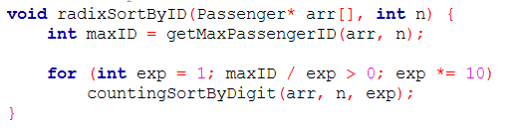
Figure 32: Radix Sort by ID
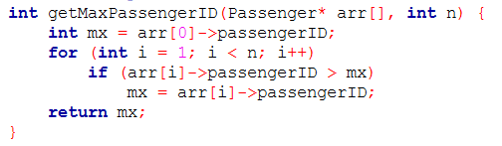
Figure 33: Get Max Passenger ID
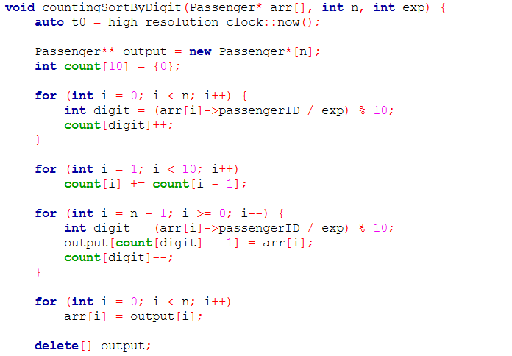
Figure 34: Counting Sort By Digit
Radix sort is implemented in generating the general report, which is sorted by passenger ID. It works digit-by-digit, where counting sort is being applied within each pass. At the beginning, the largest passenger ID is being allocated in order to define the number of digits required to be processed.
Within the function, getMaxPassengerID, an integer variable mx, is initialized to store the largest passenger ID. At the start of the function, the variable holds the value of the first passenger ID. Then the passenger ID is being compared to the next passenger ID, if the next passenger ID is larger than the value in ‘mx,’ then the variable is updated. This process occurs repeatedly until it reaches the end of the array. Then the largest passenger ID is returned.
After defining the maximum passenger ID, the function determines the number of digits needed to be processed with a loop. It starts with ones digit (exp = 1) and continues until there are no digits left. Within each loop, a similar logic for counting sort applied in other areas of the system is executed. Similarly, the counting sort function sort passengers according to the specific digit of their passenger ID through calculating the number of occurrences of each digit (0-9). A temporary array is then initialized to store the correct position of the passengers.

Bubble Sort
Definition
Similar to certain algorithms, bubble sort is also a compariso-based algorithm that repeatedly scans an array and compares two adjacent records with a specific sorting key. If the records are in the wrong order, they are swapped. When no swaps occur anymore in a pass, the algorithm stops to ensure memory optimization which improves performance.

Areas of Implementation
Bubble sort is convenient to be practiced when:
- Dataset being handled is small
- Elements are partially sorted initially
- For educational or comparison purposes
- Simplicity is prioritized over performance optimization

In this system, this algorithm is applied in:
- All features requiring sorting processes: Sorted report, Filtered report
- For comparison purposes

Practicality
Advantages
- Comprehensive and easy to implement: Logic is straightforward, which makes debugging and designing simple
- Assured stability: Similarly, it preserves the initial order of the elements having equal keys
- Minimal space usage: In-place algorithms like bubble sort requires constant amount of additional memory space
- Early termination: If no swaps occur during a pass, the algorithm terminates the process prematurely, improving performance optimization
Disadvantages
- Poor time complexity of O(n^2) in average and worst cases, which is highly inefficient for large datasets
- Performance is heavily dependent the number of elements in the dataset, making this algorithm to scale poorly
- Impractical for large datasets sorting

Justification: Practicality in the System
The purpose of the application of bubble sort in this airline flight reservation system is used to compare against other algorithms applied, including radix sort, counting sort, and merge sort. In comparison to other more efficient algorithms implemented in the system, it highlights the difference of bubble sort and the other algorithms in terms of time and space complexity.
According to research, bubble sort has proven to be time-consuming despite being memory space efficient. Its primary objective is simplicity to allow easier designing and debugging, which makes it an ideal solution to illustrate differences between various algorithms.

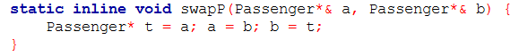
Figure 35: Swap Passenger
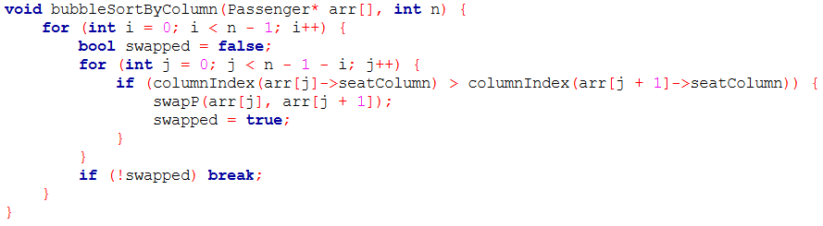
Figure 36: Bubble Sort by Column
Bubble sort is implemented in sorted reports (Seat Column, Seat Row, Flight Class, Passenger Name, Flight ID) and the general report (Passenger ID). The figure above illustrates the function responsible for sorting the passenger records according to the seat columns. The same logic and code structure are implemented for sorting the report by other attributes but with the only difference in the value being compared.
The outer loop ensures that the passenger records are being scanned repeatedly until all the records are sorted. A boolean is initialized in order to determine whether any swapping has occurred during a pass.
For the inner loop, it is responsible for comparing adjacent elements within the Passenger array that are yet to be sorted. The values of the adjacent passenger records are being compared, if the left passenger’s compared value is greater, then the order is wrong. The pointers for the two compared passengers will be swapped through the helper function, ‘swapP,’ and the boolean is set to true to indicate that at least one swap has occurred and the array has yet to be in the correct order.
Once the elements are sorted in the correct order, which can be determined if the boolean, ‘swapped,’ was false, the algorithm exits and the similar procedure to other sorting algorithms would occur. The sorted array will be copied into the original array, then the temporary memory storing the sorted data would be released.

2.2 Linked List

2.2.1 Definition
A linked list is a linear data structure which can store a collection of "nodes" connected via links i.e. pointers. Linked lists nodes are not stored at a contiguous location, rather they are linked using pointers to the different memory locations. A node consists of the data value and a pointer to the address of the next node within the linked list. A linked list is a dynamic linear data structure whose memory size can be allocated or de-allocated at run time based on the operation insertion or deletion, this helps in using system memory efficiently. Linked lists can be used to implement various data structures like a stack, queue, graph, hash maps, etc.

2.2.2 Data Container and Operations
The linked list provides a flexible container for passenger data with the following operations:
Operation | Time Complexity | Space Complexity | Description
Access by Index | O(n) | O(1) | Must traverse from head to index
Search by ID | O(n) | O(1) | Linear traversal required
Insert at Beginning | O(1) | O(1) | Update head pointer only
Insert at End | O(n) | O(1) | Traverse to tail, then insert
Insert at Position | O(n) | O(1) | Traverse to position-1, then insert
Delete by ID | O(n) | O(1) | Search + pointer update
Reverse List | O(n) | O(1) | In-place pointer reversal
Count Nodes | O(n) | O(1) | Traverse entire list
Print Report | O(n) | O(1) | Traverse and display all nodes

2.2.3 Linked List Algorithms Implemented
Singly Linked List Structure
A singly linked list in data structures is essentially a series of connected elements where each element, known as a node, contains a piece of data and a reference to the next node in the sequence. This structure allows for easy and efficient addition or removal of elements without rearranging the entire data structure, making it a flexible choice for many applications.
The linked list is implemented with a head pointer and node structure as shown below:
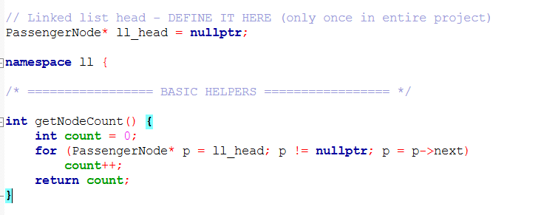
Figure 37: Get Node Count
Key Components:
- ll_head: Global pointer to the first node, initialized to nullptr
- getNodeCount(): Helper function demonstrating traversal pattern used throughout all operations

Algorithm Details
Algorithm 1: Search by Row
Purpose: Find and display all passengers in a specific seat row using linear traversal.
Algorithm Steps:
- Initialize Timer and found = false
- Start at ll_head, traverse using cur = cur->next
- For each node, check if seatRow matches target
- If match, print passenger details and set found = true
- Stop timer and display elapsed time
Advantages:
- Simple implementation with linear traversal
- Works on unsorted data
- Timer provides performance measurement
Why Linear Only:
Linked lists lack random access. Binary search requires O(1) middle element access, impossible with sequential next pointers.
Time Complexity: O(n) — must check all nodes
Space Complexity: O(1) — only loop variable
Implementation:
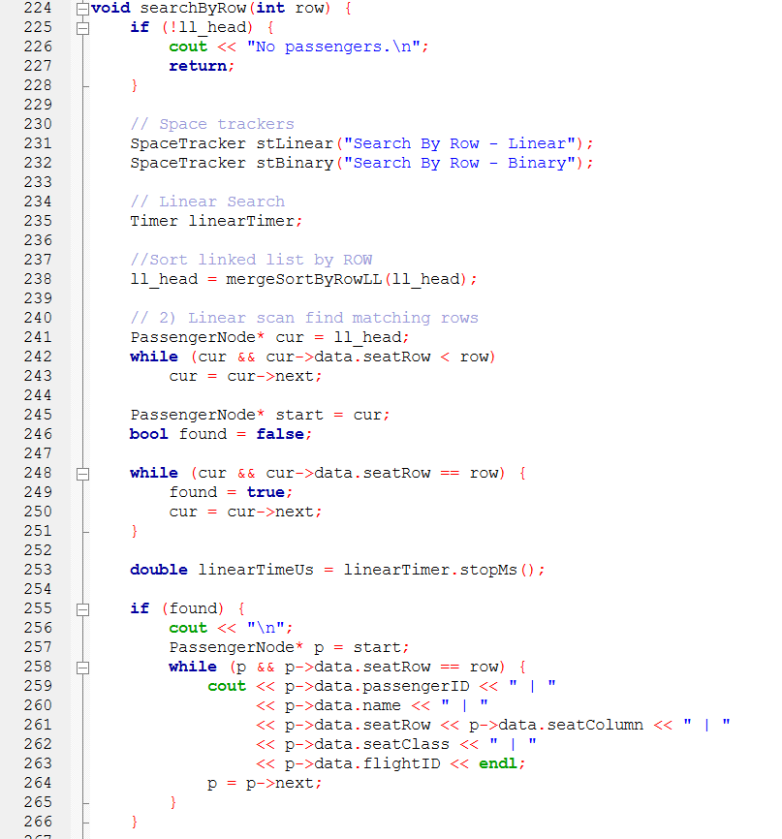
Figure 38: Search By Row

Algorithm 2: Search by Class
Purpose: Find and display all passengers in a specific flight class.
Algorithm Steps:
- Start at ll_head
- Traverse list using p = p->next
- For each node, check if seatClass matches target class
- If match, print passenger details
- Continue until nullptr reached
Time Complexity: O(n) — must check all nodes
Space Complexity: O(1)
Implementation:
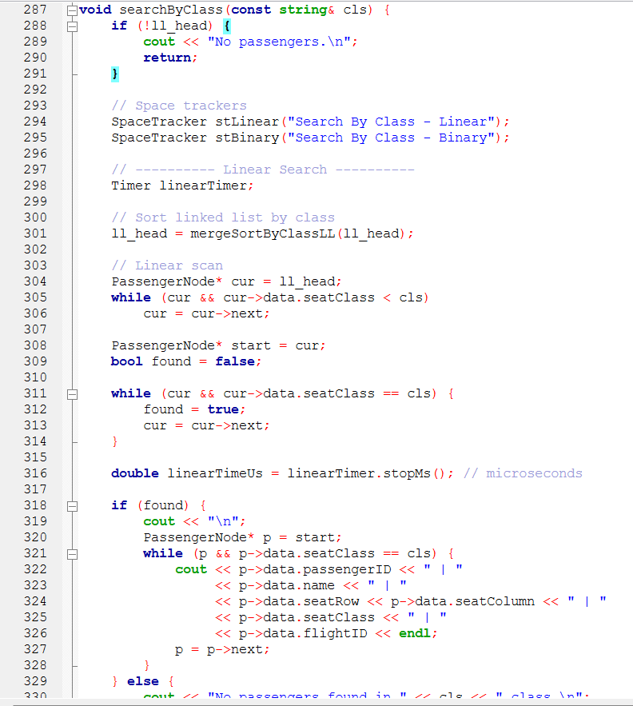
Figure 39: Search By Class

Algorithm 3: insertAtBeginning(Passenger data)
Purpose:
Inserts a new passenger node at the beginning of the list. Most efficient insertion method for linked lists with constant time complexity.
Algorithm:
- Create new node with passenger data
- Point new node's next to current head
- Update head to point to new node
Advantages:
- O(1) time complexity - instant operation
- No traversal required
- Works on empty lists
Complexity: Time O(1), Space O(1)
Implementation:
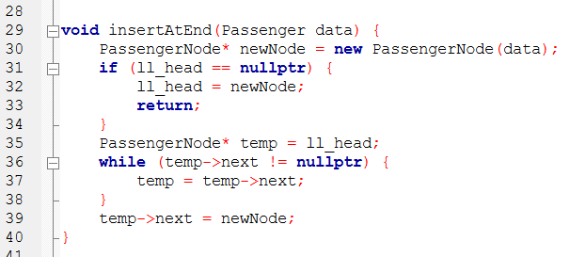
Figure 40: Insert at End

Algorithm 4: insertAtPosition(Passenger data, int pos)
Purpose: Insert a passenger at a specific position in the list. Provides flexibility for maintaining sorted order.
Algorithm Steps:
- If position ≤ 1 or list empty, insert at beginning
- Start from head and traverse to position-1
- Keep track of current position with counter
- Create new node
- Link new node to next node, link previous node to new node
Edge Cases Handled:
- Position ≤ 1: Inserts at beginning
- Empty list: Inserts at beginning
- Position > list length: Inserts at end
Time Complexity: O(n) — position-based traversal
Space Complexity: O(1) — single node allocation
Implementation:
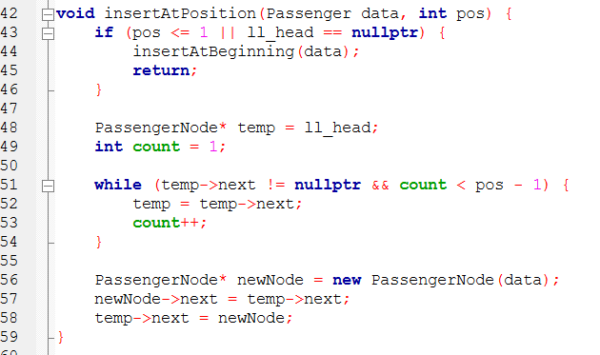
Figure 41: Insert at Position

Algorithm 5: reverseLinkedList()
Purpose: Reverse the order of nodes in-place using three-pointer technique.
Algorithm Steps:
- Initialize three pointers: prev = nullptr, current = ll_head, next = nullptr
- While current is not null:
- Save next node (next = current->next)
- Reverse current's pointer (current->next = prev)
- Move prev and current forward
- Set head to prev (last node becomes first)
Time Complexity: O(n) — single pass through list
Space Complexity: O(1) — in-place reversal
Implementation:
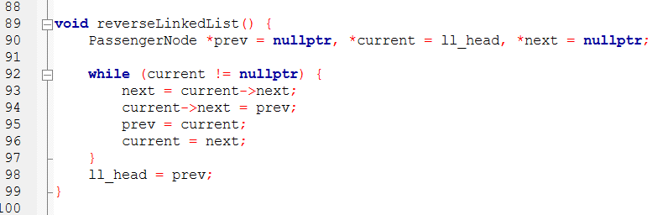
Figure 42: Reverse Linked List

Algorithm 6: loadFromFile(const string& filename)
Purpose: Load passengers from CSV file using insert-at-beginning approach.
Algorithm Steps:
- Open file and check if successful
- Skip header line
- For each data line:
  - Parse CSV fields (ID, name, row, column, class, flight)
  - Create Passenger object
  - Create new node and insert at head
  - Increment counter
- Display count and timer result
Time Complexity: O(n) — process n passengers
Space Complexity: O(n) — n nodes created
Implementation:
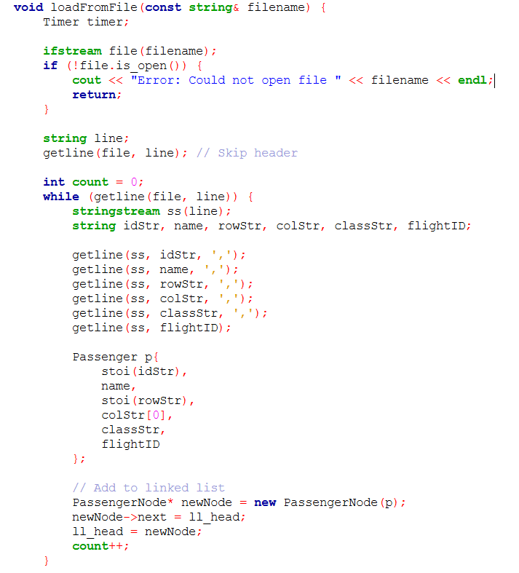
Figure 43: Load From File
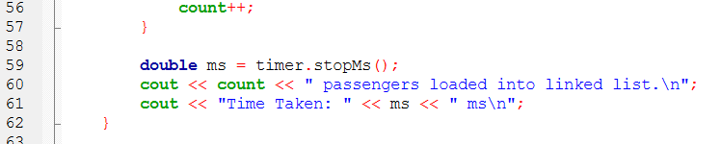
Figure 44: Output for function Load From File

Algorithm 7: cancelReservation()
Purpose: Delete a passenger reservation by ID using pointer bypass technique.
Algorithm Steps:
- Check if list is empty
- If target is head node, move head forward and delete old head
- Otherwise, traverse with prev/current pointers to find target
- If found, bypass node (prev->next = current->next) and delete
- Display success or not-found message
Time Complexity: O(n) — search for target
Space Complexity: O(1) — no extra memory
Implementation:
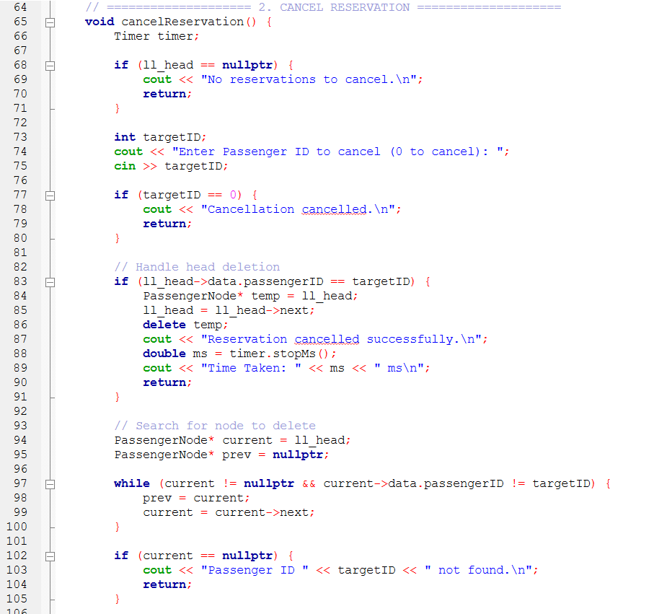
Figure 45: Cancel Reservation
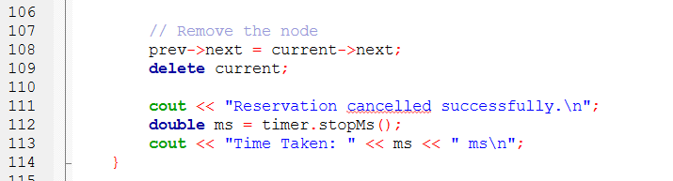
Figure 46: Output for Cancel Reservation

Algorithm 8: displayManifest()
Purpose: Display all passengers in formatted table with timer.
Algorithm Steps:
- Check if list is empty
- Print formatted header
- Traverse list, printing each passenger's details
- Count passengers during traversal
- Display total count and timer result
Time Complexity: O(n) — traverse entire list
Space Complexity: O(1) — only counter variable
Implementation:
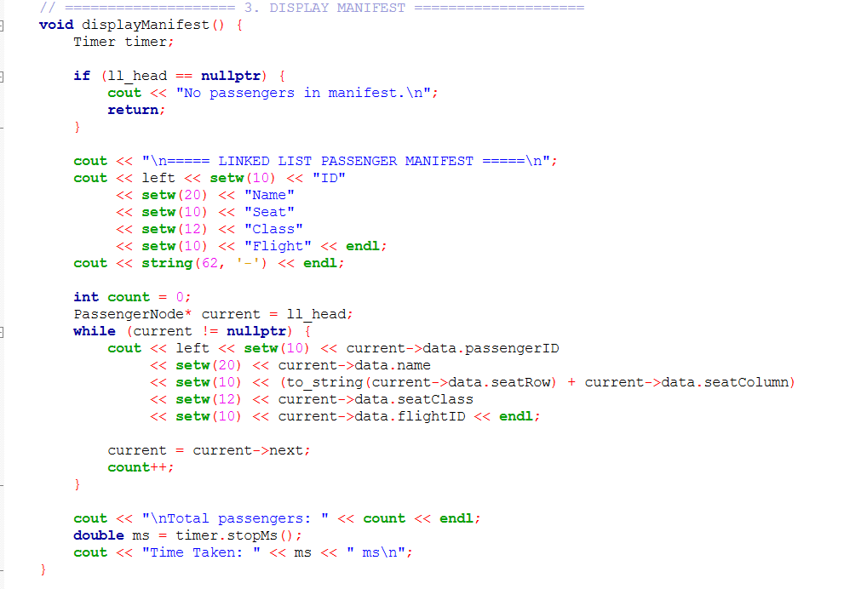
Figure 47: Display Manifest

Algorithm 9: displaySeatingChart()
Purpose: Display 30×6 seating grid showing occupied seats for specific flight.
Algorithm Steps:
- Get flight ID from user and validate
- For each row (1-30) and column (A-F):
  - Traverse list to check if seat is occupied
  - Print [X] for occupied, [ ] for empty
- Add class section labels (First/Business/Economy)
- Display timer result
Time Complexity: O(30×6×n) = O(n) — check each seat against list
Space Complexity: O(1) — no extra data structures
Implementation:
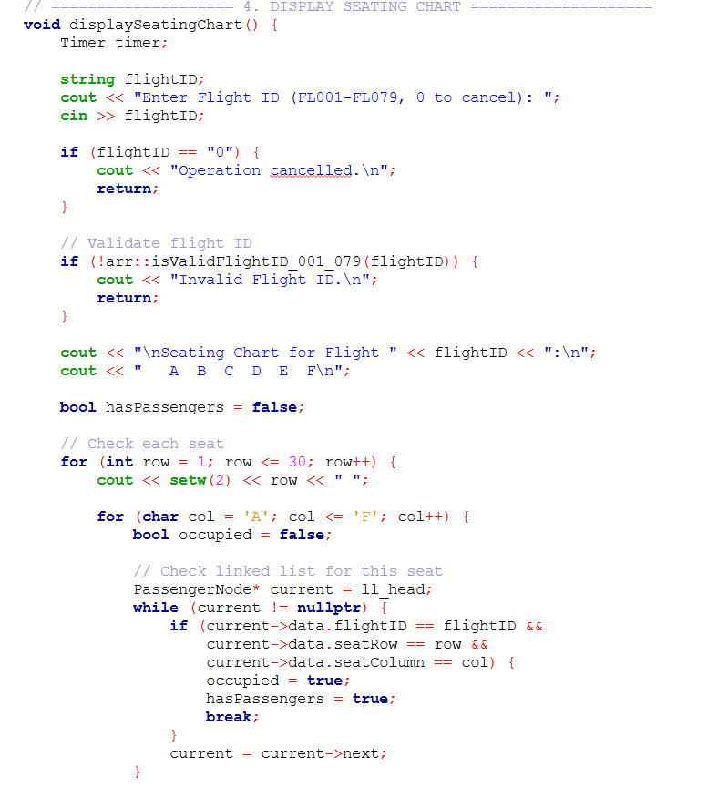
Figure 48: Display Seating Chart
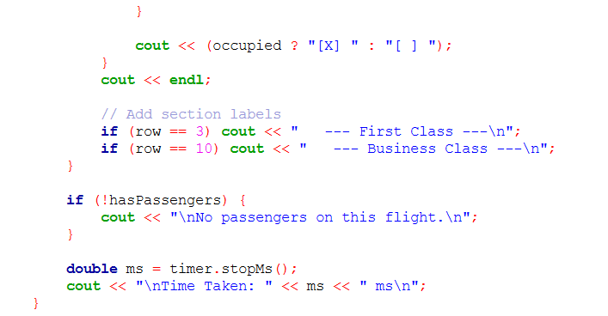
Figure 49: Output for Function Display Seating Chart

Algorithm 10: addPassenger()
Purpose: Interactive passenger addition with validation and insert-at-beginning.
Algorithm Steps:
- Generate new ID (max existing + 1)
- Get and validate name input
- Get and validate flight ID
- Get and validate seat class (Economy/Business/First)
- Get and validate seat row (class-specific range)
- Get and validate seat column (A-F)
- Check if seat already booked (traverse list)
- If available, create node and insert at head
- Display confirmation and timer
Time Complexity: O(n) — seat availability check
Space Complexity: O(1) — single node creation
Implementation:
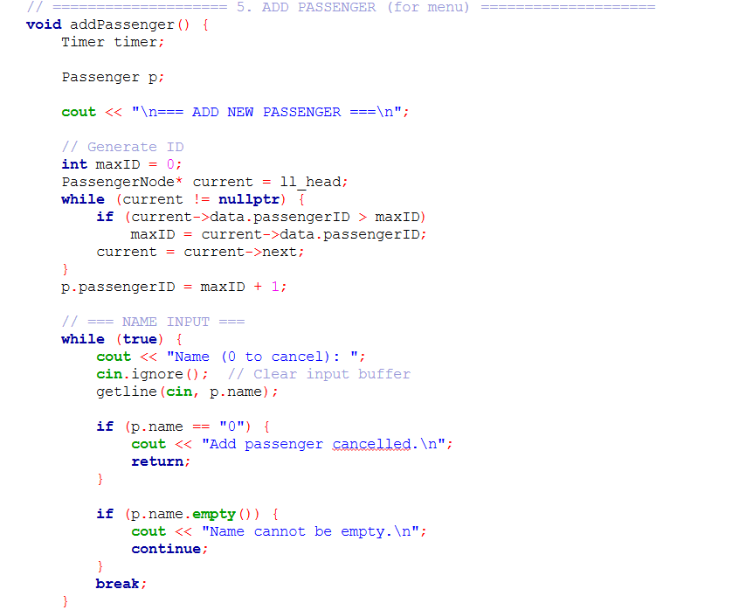
Figure 50: Automatic ID generation by traversing list to find maximum

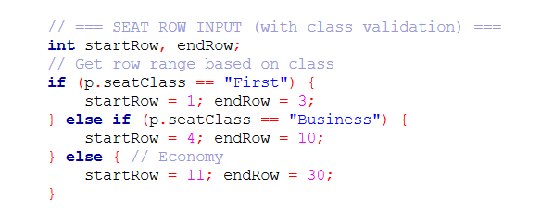
Figure 51: Class-specific row validation (First: 1-3, Business: 4-10, Economy: 11-30)
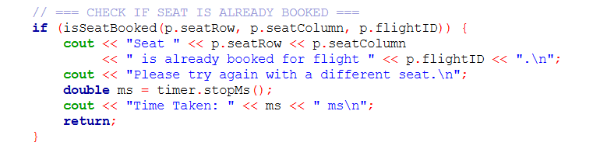
Figure 52: Seat availability check and insert-at-beginning operation
Algorithm Summary Table
Table
Copy
# | Algorithm | Time | Space | Menu Access | Key Feature
1 | searchByRow | O(n) | O(1) | Menu 3 | Linear traversal
2 | searchByClass | O(n) | O(1) | Menu 4 | String comparison
3 | insertAtEnd | O(n) | O(1) | Helper | Tail insertion
4 | insertAtPosition | O(n) | O(1) | Helper | Position-based
5 | reverseLinkedList | O(n) | O(1) | Helper | 3-pointer swap
6 | loadFromFile | O(n) | O(n) | Auto on start | CSV loading
7 | cancelReservation | O(n) | O(1) | Menu 2 | Delete by ID
8 | displayManifest | O(n) | O(1) | Menu 5 | Full listing
9 | displaySeatingChart | O(n) | O(1) | Menu 6 | Grid display
10 | addPassenger | O(n) | O(1) | Menu 1 | Validated insert

3.0 Input-Output Screenshots

3.1 Array

3.1.1 Reservation
Linear vs Binary
Input:
Linear Search | Binary Search
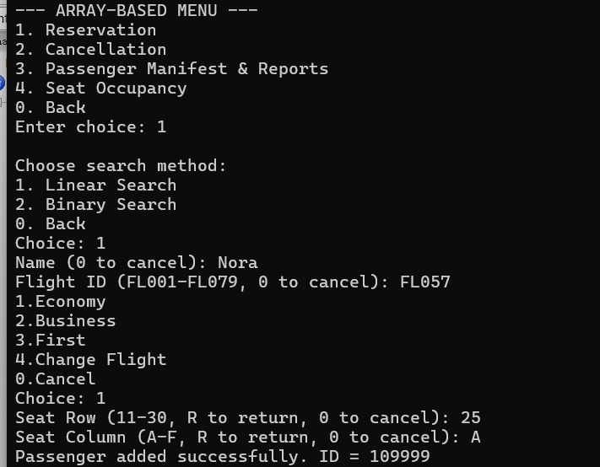  Figure 53: Reservation using Linear Search (Input) | 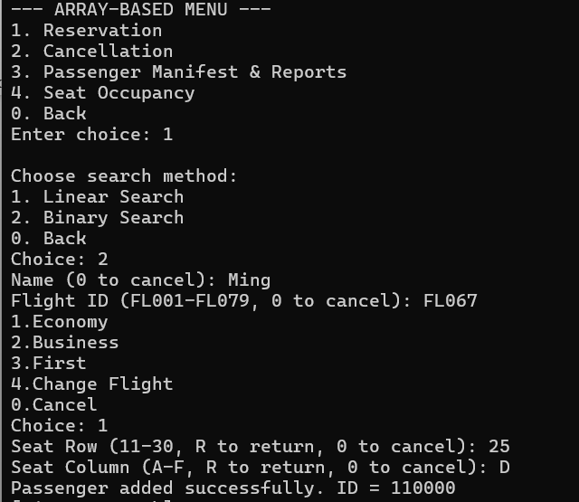  Figure 54: Reservation using Binary Search (Input)

Both Figure inside the table on the above show the system flow for reservation part. The system flow of reservation part starts from the main menu for array which is Array-Based Menu. After select reservation by entering number at the main menu, user will be required to choose the search method they prefer to use. Users must enter the details which asking on the menu including name, Flight ID, class, seat row, and seat column. After finding the largest passenger ID in the CSV file using the search function, the system will automatically generate a new passenger ID based on that ID number and save the new ID and its details in the CSV file.

Output:
Linear Search | Binary Search
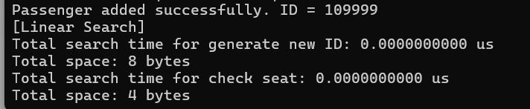  Figure 55:Time and Space usage (Linear Search) | 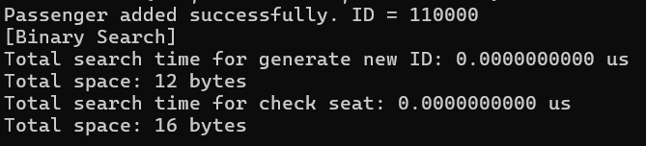  Figure 56: Time and Space usage (Binary Search)

The system implements both linear and binary search algorithms for the reservation function, specifically for two critical operations, which are generating new passenger IDs and checking seat availability. For ID generation, linear search scans through all existing passenger records sequentially to identify the maximum ID value, while binary search employs a divide-and-conquer approach on sorted data to efficiently locate the maximum ID. For seat availability checks, linear search examines each booking record in order to detect conflicts, whereas binary search requires sorting records by flight, row, and column before performing its optimized lookup.
During testing, both search algorithms have demonstrated identical execution times of 0 microseconds for reservation operations. This occurs because the dataset size for individual flight seat checks and ID generation is sufficiently small that both algorithms complete their tasks in less than a microsecond, resulting in rounded-down timing measurements. The auxiliary space consumption, however, differs between approaches, with binary search requiring additional memory for sorting operations and maintaining search range variables.

Algorithm | Time Complexity | Space Complexity (Auxiliary Space)
Linear Search | O(n) | O(1)
Binary Search | O(log n) for search, O(n log n) with sorting | O(1) for search, additional for sorting

Time Complexity Analysis
According to the system outputs on Figure, both linear and binary search algorithms complete reservation operations in negligible time (0.0000000000 μs). Linear search performs a sequential scan through passenger records for both ID generation and seat checking, with best-case time complexity O(1) and worst-case O(n). Binary search theoretically offers O(log n) efficiency for the search phase but requires O(n log n) preprocessing for sorting when data is unsorted. The measured times of 0 μs indicate either highly efficient execution on current dataset sizes or timing measurement granularity limitations that round sub-microsecond operations to zero.

Space Complexity Analysis
Besides, the system output shows minimal differences for auxiliary space usage. Linear search requires 8 bytes for ID generation and 4 bytes for seat checking, while binary search requires 12 bytes and 16 bytes. Linear search utilizes only basic loop counters and temporary variables, thus it will maintain constant O(1) space complexity regardless of dataset size. However, binary search employs additional variables for tracking search ranges from left to right and requires temporary storage for sorting operations, resulting in slightly higher but still constant space overhead that remains independent of dataset scale.

Comparative Evaluation
Aspect | Linear Search | Binary Search
Time Complexity | O(n) | O(log n) for search, O(n log n) with sorting
Execution Speed | Fast for small datasets | Very fast for searches after sorting
Space Complexity | Lower (4-8 bytes) | Higher (12-16 bytes) due to sorting overhead
Scalability | Limited for large datasets | Excellent for large datasets if sorted
Practicality | Ideal for simple operations and small datasets | Suitable when performance optimization is prioritized
Data Requirements | Works on unsorted data | Requires sorted data or includes sorting cost

3.1.2 Cancellation
Linear vs Binary
Input:
Linear Search | Binary Search
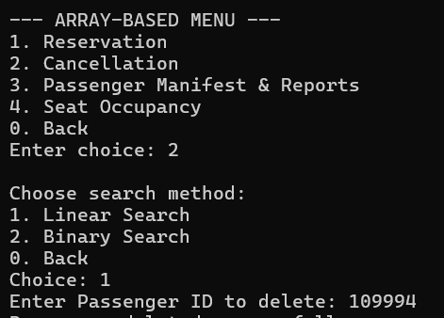  Figure 57: Cancellation using Linear Search (Input) | 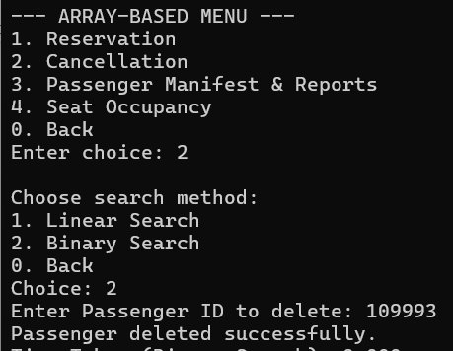  Figure 58: Cancellation using Binary Search (Input)

The Figure on the above show the system flow for cancellation part. The flow starts from the main menu for array which is Array-Based Menu, user will be required to choose the search method they prefer after select Cancellation at the main menu. After choosing the method by entering number, user require to enter the passenger ID they want to delete.
Output:
Linear Search | Binary Search
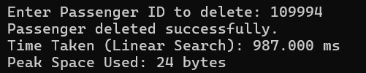  Figure 59: Time and Space usage (Linear Search) | 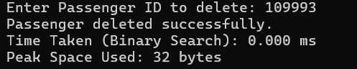  Figure 60: Time and Space usage (Binary Search)

The system implements both linear and binary search algorithms for the cancellation function, specifically comparing only the core search operations while treating data preparation as separate concerns. For linear search, the search algorithm operates directly on unsorted data with O(n) complexity. For binary search, the timing and space measurements intentionally exclude the mandatory O(n log n) sorting pre-processing to isolate and compare the pure search efficiency of O(log n) binary search against O(n) linear search.

This comparison methodology is designed to evaluate the inherent search efficiency of each algorithm under their respective optimal conditions. The time taken to execute binary search is rounded down to 0 ms, indicating its theoretical superiority in terms of speed when handling sorted data, while the measured 32 bytes of space reflects the additional variables needed to manage the binary search's divide and conquer approach..
Algorithm | Time Complexity | Space Complexity
Linear Search | O(n) | O(1)
Binary Search | O(log n) | O(1)

Time Complexity Analysis
Based on the system output, binary search has been recorded to complete its execution in less than 1 ms, which has been rounded down to 0 by the timing system. This demonstrates its exceptional efficiency for the pure search operation. In contrast, linear search taken 987.000 ms to complete the execution due to its sequential scanning approach, where every element within the array must be examined until the target is found or the array is exhausted.
Binary search achieves its enhanced performance through a divide and conquer strategy with a search time complexity of O(log n), where the logarithmic nature reflects how the search range halves exponentially with each comparison. However, in this analysis considers only the search phase. This is because the prerequisite O(n log n) merge sort operation required to prepare unsorted data for binary search is excluded from measurement. Linear search maintains O(n) complexity throughout, operating effectively on unsorted data without preprocessing overhead.

Space Complexity Analysis
As illustrated in the figures above, the peak space usage for binary search algorithm is recorded to be 32 bytes while linear search has used 24 bytes. Linear search demonstrates slightly better space efficiency, requiring only basic variables including a loop counter (4 bytes), temporary pointer (8 bytes), target identifier (4 bytes), result index (4 bytes), and timing variable (8 bytes), totaling 28 bytes (rounded to 24 bytes in measurement). This minimal auxiliary memory usage results from its straightforward sequential approach, with space complexity remaining O(1) regardless of dataset size.
Binary search consumes marginally more space at 32 bytes due to its additional range management variables for tracking search boundaries ('left', 'right', 'mid') along with the same basic variables used by linear search. Despite requiring more variables for its divide-and-conquer mechanism, binary search maintains constant O(1) space complexity for the pure search operation, as these additional allocations are fixed in size and independent of input scale. The measured difference of 8 bytes represents the overhead of binary search's more complex algorithmic structure while both algorithms remain highly memory-efficient.

Comparative Evaluation
Aspect | Linear Search | Binary Search
Pure Search Speed | O(n) sequential scanning | O(log n) divide-and-conquer
Search Space Usage | 24 bytes | 32 bytes
Data Dependency | Works immediately | Requires sorted data
Algorithm Efficiency | Simple but slower | Complex but faster
Fairness of Comparison | Complete operation measured | Only search phase measured

By measuring only the search phases, this comparison validly demonstrates binary search's superior searching efficiency when operating on properly sorted data. However, for practical implementation decisions, the total cost including sorting overhead must be considered, as linear search may be more efficient for single operations on unsorted data despite binary search's better pure search performance. Although binary search's superior time performance, linear search demonstrates better space efficiency in this implementation, using 24 bytes compared to binary search's 32 bytes, highlighting the trade-off between time optimization and memory conservation.

3.1.3 Manifest and Seat Report
1. General Report
1 | 2
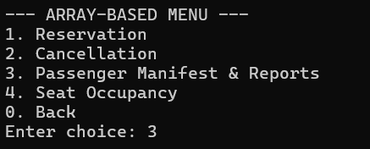  Figure 61: Passenger Manifest & Reports | 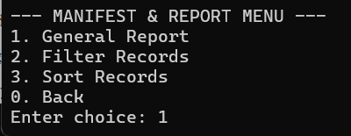  Figure 62: General Report

Within the array-based menu for the reservation system, the user selects the action they want to perform within the main menu, where the report management submenu can be redirected to through the input, 3. After entering 3, the user will be guided to the submenu for managing passenger manifest and report management. In order to display all existing reservation records, the user inputs 1.

Output
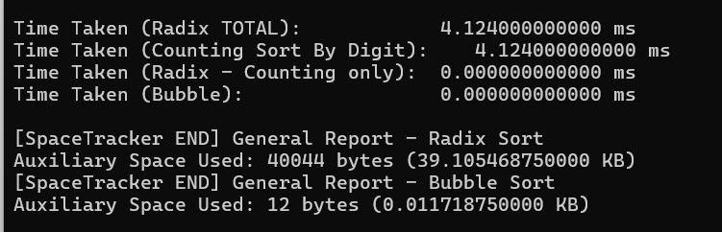
Figure 63: Time and Space usage for General Report

The general report displays all the flight reservation records for all passengers, sorting based on Passenger ID, which possesses the traits of being numeric, non-negative, consistent format, and of large quantity. As the general report processes the entire dataset, performance and scalability are prioritized.
The algorithm, radix sort, operates through implementing counting sort on each digit of the passenger ID. Therefore, according to the output, the actual sorting algorithm only took a duration close to zero to complete its execution. This output is expected with the theoretical design of this algorithm as the counting sort is the only major operation during the sorting process. Therefore, the overall execution time is dominated by counting sort, consequently resulting in an equal measured time.

Algorithm | Time Complexity | Space Complexity (Auxiliary Space)
Radix Sort | O(n * d) | O(n + k)
Bubble Sort | O(n²) | O(1)

Time Complexity Analysis
According to the output from the system, it shows that both radix and bubble sort algorithms appear to be 0 ms. This is because the size of the dataset is relatively small, which makes the difference of the two algorithms in terms of time complexity to be similar since bubble sort may have completed within one millisecond which caused the measured time to round it to zero.
Theoretically, radix sort is faster compared to bubble sort, which is a comparison-based algorithm. Instead of comparing elements within the array repeatedly, it sorts the data digit by digit through counting sort, which calculates the frequency of each digit in the datasets. Since passenger IDs are in numerical format and of small and fixed range, the number of passes is limited, which gives the time complexity of O(n * d), where n is the number of passengers and d is the number of digits. Since d is a small and fixed value, the time complexity is often rounded to O(n).
Compared to radix sort, bubble sort uses an approach where comparisons are performed on the adjacent elements within the array and swaps their positions if they are in the incorrect order. This requires all the element to be scanned repeatedly in order to ensure that all the elements are of the correct order, therefore resulting in a time complexity of O(n²) as the algorithm performs scanning of the entire array multiple times until elements are sorted in the correct order. As a result, when the size of the array increases gradually, the execution time required for bubble sort also increases simultaneously.

Space Complexity Analysis
According to the output shown above, radix sort has consumed more auxiliary memory compared to bubble sort algorithm.
Radix sort requires a larger auxiliary memory space compared to bubble sort as it is heavily dependent on counting sort as a part of the operation, requiring additional arrays to store intermediate results and digit frequencies temporarily. Additional elements required include:
Temporary Array: As an extra array is initialized to store passenger records temporarily, the size depends on the number of passengers, which significantly increases the space required.
Count Array: A small, fix-sized array is implemented to store the number of occurrences for all digits (0-9) in the operation
Extra Variables: Variables for digit traversal and keeping track of indexes
Bubble sort was implemented for comparison purposes. This algorithm shows that it requires a longer time to operate compared to radix sort algorithm. Since it is slower, it requires significantly lesser amount of auxiliary memory compared to radix sort. It implements comparisons of elements and swaps elements within the original array, requiring lesser elements for the process. Therefore, it requires no temporary arrays for the operation, and the memory usage remains the same without regards of the input size.

Comparative Evaluation
Aspect | Radix Sort | Bubble Sort
Time Complexity | Low | High
Execution Speed | Very fast | Very slow
Space Complexity | Larger | Smaller
Scalability | High | Low
Practicality | More practical | Impractical

2. Sorted Report
Merge vs Bubble
- Sort by Name
Input
1 | 2
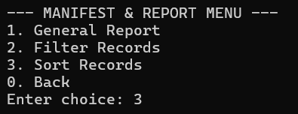  Figure 64: Sort Records | 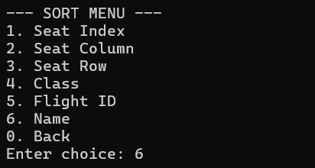  Figure 65: Sort by Name
In order to view sorted report according to a specific attribute, the user has to input ‘3’ in the array-based main menu to be redirected to the submenu for managing reports and passenger manifest. Within the submenu, the user selects the operation represented by the value 3 to sort the report. Then the attributes that support sorting is displayed and the user can select the attribute they want to sort according to.

Output
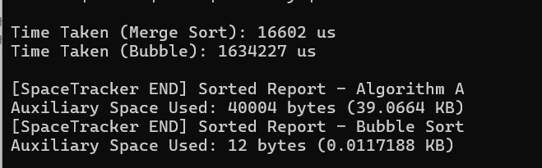
Figure 66: Time and Space usage for Generate Sorted Report by Name
The figure above shows the process of generating a passenger report sorted by name. The report is being sorted with a prefix manner. It allows the user to view the passenger manifest in an alphabetically ordered listing, enabling quicker location of specific passengers and improving data readability. The generation of this report has implemented two sorting algorithms, including merge sort and bubble sort, which are also implemented in sorted report by flight ID.
Merge sort algorithm uses a divide-and-conquer sorting scheme where subarrays are being created repeatedly through dividing datasets, then sorting the subarrays before merging them back into a sorted order. The three primary steps of merge sort includes: divide, conquer, and merge.
Divide: Passengers are divided into equal halves, then repeatedly being divided until all subarrays only contain one element
Conquer: Subarrays containing only one passenger record are being compared. The smaller value element is placed into a temporary array. This process repeats until all passengers of subarrays have been placed into the temporary array.
Merge: The sorted elements in the temporary array are copied back into the original array through recursive calls.

Algorithm | Time Complexity | Space Complexity (Auxiliary Space)
Merge Sort | O(n log n) | O(n)
Bubble Sort | O(n²) | O(1)

Time Complexity Analysis
Based on the system output as illustrated in the figures above, merge sort has completed its execution with a time of less than 20,000 microseconds as recorded by the system, which is noticeably lesser than the execution time taken by bubble sort. The reason behind is because of the divide-and-conquer scheme of this algorithm. The first process of this algorithm is splitting the array into half multiple times until subarrays only consist of one single element. After that, two subarrays are compared and combined together in the correct order. Therefore, as a result, it allows a time complexity consistency where the time is increased logarithmically. This indicates that merge sort is an ideal solution for handling large datasets.
On the contrary, bubble sort is implemented through repeated comparisons of adjacent elements within the data container and swapping them if they are not in the correct order. This process is performed repeatedly until all elements are correctly ordered. Therefore, it is given the time complexity of O(n²) in an average to worst case scenario while maintaining a time complexity of O(n) in the best-case scenario. This is because the time efficiency is heavily dependent on the number of swaps required on the original dataset. If the original dataset is in an excessively disorganized state, bubble sort requires excessive time usage to complete its execution.
In practical scenarios where elements are not sorted initially within arrays, bubble sort is a lesser efficient approach when managing large datasets. In real-world environments, excessively large datasets are often being handled. Therefore, many comparisons and swaps are required by bubble sort, making it less ideal for practical implementation especially when performance is prioritized.

Space Complexity Analysis
In order to ensure performance optimization, merge sort utilizes more auxiliary memory compared to bubble sort to store elements temporarily during the sorting process. As proven in the output above, approximately 40 KB of memory space have been occupied by this algorithm to contain intermediate sublists during the process. While this approach consumes more memory space compared to in-place algorithms like bubble sort, it has significantly enhanced the scalability and performance of the system.
Compared to merge sort algorithm, bubble sort does not require as much memory space for execution as minimal additional resources are required for the execution. According to the output shown above, the algorithm has only used a few bytes for the entire sorting process, making it a more memory-efficient approach. However, as it only utilizes a small space in the memory, the time efficiency of this sorting algorithm is also reduced when handling large datasets.

Comparative Evaluation
Aspect | Merge Sort | Bubble Sort
Time Complexity | Low | High
Execution Speed | Fast | Very slow
Space Complexity | Larger | Smaller
Scalability | High | Low
Practicality | More practical | Impractical

- Sort by Flight ID
Input | Output
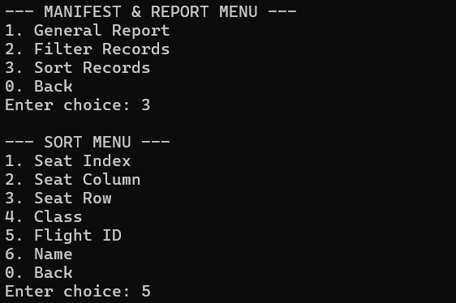  Figure 67: Sort by Flight ID | 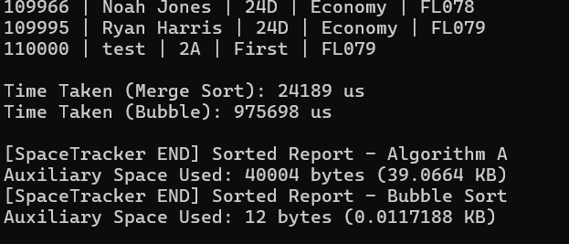  Figure 68: Time and Space usage for Sort by Flight ID

Counting vs Bubble
- Sort by Seat Column
Input
1 | 2
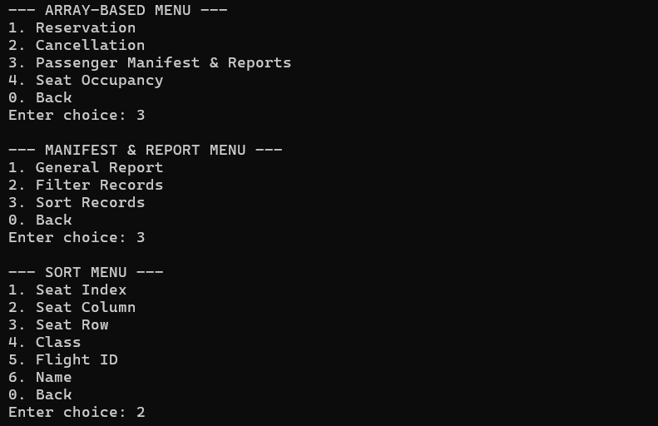  Figure 69: Sort Records | Figure 70: Sort by Seat Column

Output
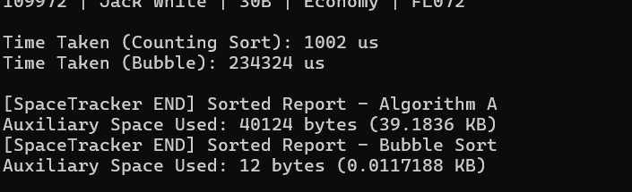
Figure 71: Time and Space usage for Sort by Seat Column
The figure above illustrates the generation of the general report sorted based on seat columns. This feature has implemented both counting and bubble sorting approaches, which has also been applied in the general report sorting by seat rows, seat index, and flight class, as these attributes have limited and fix range of possible values.
Seat Columns: A to F
Seat Rows: 1 to 30
Flight Class: First, Business, Economy
Counting sort is a non-comparison-based solution, where the frequency of all possible key values is being determined before sorting the elements according to the counts of the keys. Therefore, making it an ideal application to various attributes. Instead of comparing passengers repetitively, which requires a large amount of time, counting sort enables a smaller usage of time through determining the number of passengers falling into each category. It makes the system more efficient and predictable.
Algorithm | Time Complexity | Space Complexity (Auxiliary Space)
Counting Sort | O(n + k) | O(n)
Bubble Sort | O(n²) | O(1)

Time Complexity Analysis
According to research, counting sort has a time complexity of O(n + k), where n represents the number of elements and k indicates the range of possible key values. For the existing system, the possible values for seat column, seat row, seat index, and flight class, are of small and fixed ranges, enabling a small value of k. As a result, the execution of this algorithm completes extremely faster (Possibly less than one microsecond). When the execution time is less than one microsecond, the system rounds it up to 0 (Refer to figure 73).
Nonetheless, the algorithm, bubble sort performs repeated comparisons and swaps with a time complexity of O(n²), which causes a longer execution time compared to counting sort that is more measurable at a microsecond level. As the number of passengers gradually increase in the future, bubble sort becomes less efficient in parallel as its efficiency is heavily dependent on the number of comparisons and swaps required during the sorting process.
Overall, counting sort outperforms bubble sort as it performs sorting through determining the number of occurrences for each key value instead of comparisons of elements within the dataset.

Space Complexity Analysis
According to the output above, counting sort requires more memory usage compared to bubble sort as it needs more resources in order to ensure performance optimization. Similarly, merge sort has used approximately 40 KB of auxiliary space while bubble sort only used several bytes. As the range of possible key values for the system is small ranged, the output shows lesser space in the memory being occupied compared to real-world applications where the value for k is possibly significantly larger. Counting sort is more space consuming as it requires space for:
Count Array: Containing the range of key values
Output Array: Containing number of passengers
Compared to counting sort, bubble sort performs in-place sorting, where elements are being sorted within the original array containing passenger records, making it more memory-efficient compared to other sorting algorithms as it does not require additional resources while simultaneously operating at a much slower speed.

Comparative Evaluation
Aspect | Counting Sort | Bubble Sort
Time Complexity | Low | High
Execution Speed | Very Fast | Very slow
Space Complexity | Larger | Smaller
Scalability | High | Low
Practicality | More practical | Impractical

- Sorted Report by Row
Input | Output
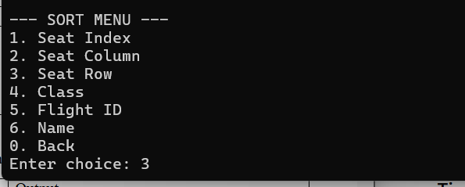  Figure 72: Sort Report by Row | 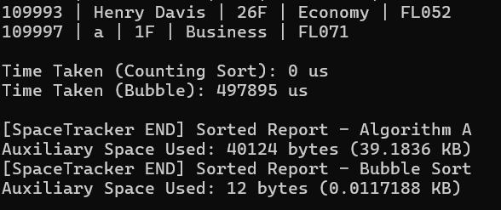  Figure 73: Time and Space Usage for Sort Report by Row

- Sorted Report by Seat Index (Row + Column)
Input | Output
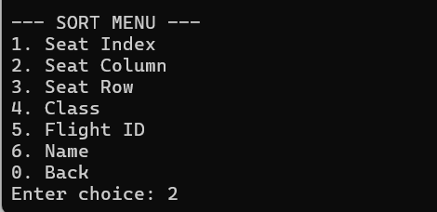  Figure 74: Sorted Report by Seat Index | 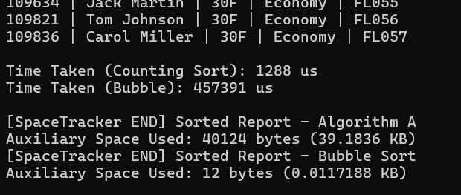  Figure 75: Time and Space Usage for Sorted Report by Seat Index

- Sorted Report by Class
Input | Output
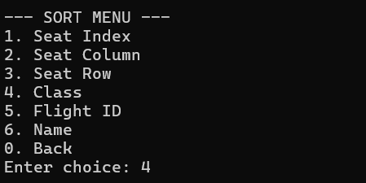  Figure 76: Sorted Report by Class | 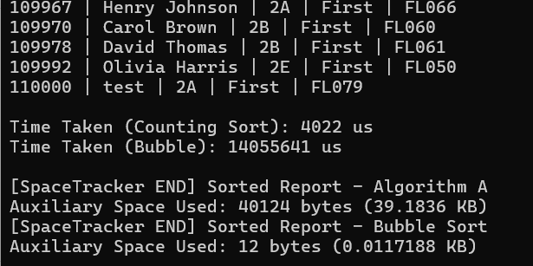  Figure 77: Time and Space Usage for Sorted Report by Class

3. Filtered Report (Linear vs Binary)
Filtered Report
- Seat Index
Input
1 | 2
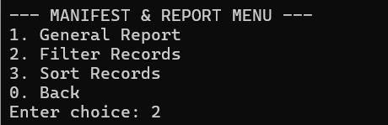  Figure 78: Filter Records | 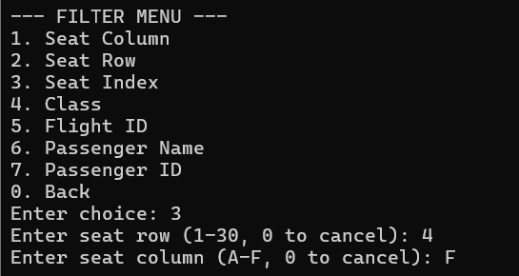  Figure 79: Filter by Seat Index

The flow begins from entering into the Report sub-menu and the user will be required to select their desired actions according to the number assigned for each task listed. To view filtered report or passenger records of specific characteristics, the user inputs the number ‘2’ into the system to enter the Filtered Report sub-menu. Within the Filtered Report sub-menu, the user selects the desired type of filter to apply through inputting the corresponding number for each attribute.
Output
1 | 2
Linear  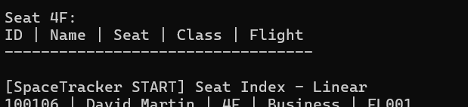  Figure 80: Seat Index (Linear Search)  Binary  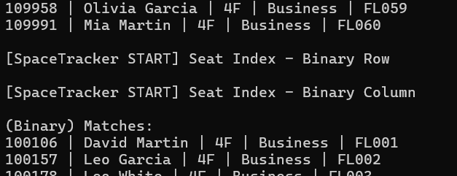  Figure 81: Seat Index (Binary Search) | 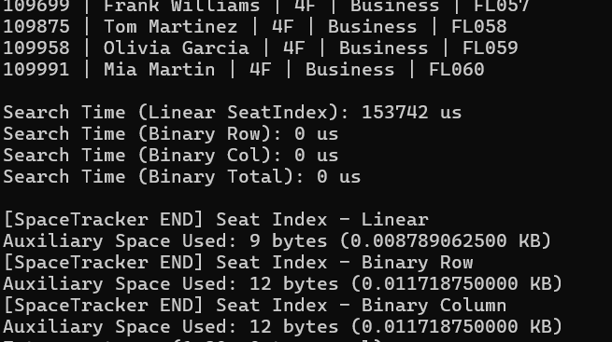  Figure 82: Time and Space Usage

The system implements both linear and binary search for the filter report feature, attributes supporting filtering include:
Seat Column: Filtered report according to specific seat column
Seat Row: Filtered report according to specific seat row
Seat Index: Filtered report according to specific seat column and row
Flight Class: Filtered report according to specific flight class
Passenger Name: Filtered report according to specific passenger name
Passenger ID: Filtered report according to specific passenger ID
Linear search is applied to go through all passenger records in a sequential manner while binary search employs repeated division on sorted arrays to enable faster lookup processes. The application of both approaches is used for comparison purposes to evaluate the difference between basic and optimized solutions.
However, during the testing process, several test cases have reported that both searching algorithms have an identical execution time of 0 us. Test cases including filtered report by seat row, seat column, and passenger ID have presented a parallel execution time of 0 us for linear and binary searches, while the other attributes have shown measurable execution times. (Refer to figure 55, figure 56, figure 84, figure 86, and figure 94)
Seat Column and Seat Rows: Small and consistent ranges
Passenger ID: Initially sorted in original report and with unique values
As seat row, column, passenger IDs only involve basic primitive comparisons, they operate exceptionally fast at the CPU level. Hence, with a small dataset, the operation completes within one microsecond, which is often rounded down to 0 by the timing system.

Algorithm | Time Complexity | Space Complexity (Auxiliary Space)
Linear Search | O(n) | O(1)
Binary Search | O(log n) | O(1)

Time Complexity Analysis
According to the output of the system, linear search has used a remarkably more time for execution compared to binary search, using approximately 0.15 seconds of execution time while binary search used less than one microsecond.
Linear search algorithm will searches all elements in an array sequentially until it found the target element or reaches the end of the array. If the target element is at the first index of the array, the linear search algorithm executes immediately and achieving a best-case time complexity of O(1). Conversely, if the target element is located at other location in the array, the algorithm's time complexity is O(n), where n is the number of array elements. Therefore, the execution time will also when the size of the array increases, the execution time also extends in parallel.
For binary search algorithm, it executes repetitive division of the search range into two halves through comparisons of the target and the middle element of the ranges. On the best case, O(1), the target is found exactly in the middle of the list of passengers. For average to worst cases, the time complexity would be O(log n), where n is the number of passengers. Contrasting to linear search, binary operates at a significantly higher speed when handling with large datasets as the number of comparisons increase logarithmically, which is less intense than linear search solution.

Space Complexity Analysis
As displayed in the output of the system, both linear and binary searches have occupied a small amount of auxiliary memory despite binary search occupying several bytes more than linear search algorithm.
The only resource required by linear search are a loop counter and temporary variables for comparison purposes. It uses lesser variables compared to binary search and is capable of operating on unsorted data. These variables have constant numerical values and are not dependent on the number of passenger records in the array. Hence, it requires no supplementary data structures for the operation, ensuring a consistent use of memory space regardless of changes of the dataset size.
On the contrary, binary search uses a rather larger auxiliary memory in order to manage additional resources for maintaining the search ranges, including variables for ‘left,’ ‘right,’ and ‘mid.’ Besides, binary search requires sorted arrays in order to execute accurately. Nonetheless, these variables also have consistent numerical values, and the required space is not influenced by the size of the dataset. Thus, this increase in memory space required for binary searches is negligible.

Comparative Evaluation
Aspect | Linear Search | Binary Search
Time Complexity | High | Low
Execution Speed | Slow | Very fast
Space Complexity | Equal to binary search | Equal to linear search
Sorting Dependency | No | Yes
Type of Data | Unsorted or sorted data | Only sorted data
Simplicity | Simpler to apply | More complex to apply
Scalability | Low | High
Practicality | Ideal for small datasets for simplicity and limited resources | Suitable for large datasets for performance optimization

- Seat Row
Input | Output
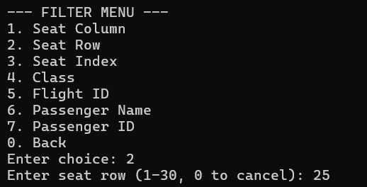  Figure 83: Seat Row | 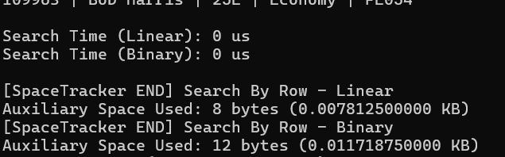  Figure 84: Time and Space Usage (Seat Row)

- Seat Column
Input | Output
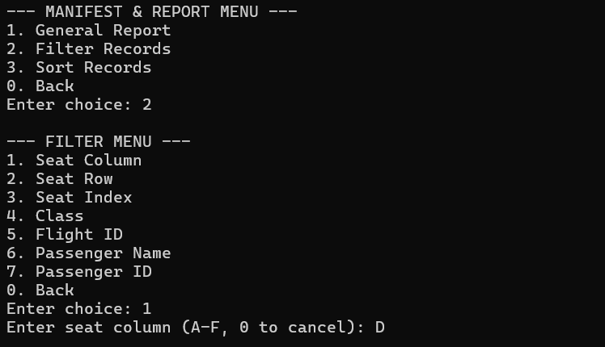  Figure 85: Seat Column | 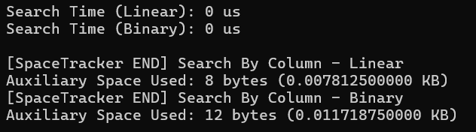  Figure 86: Time and Space Usage (Seat Column)

- Flight Class
Input | Output
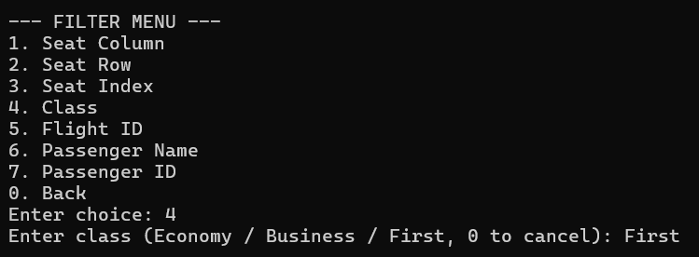  Figure 87: Flight Class | 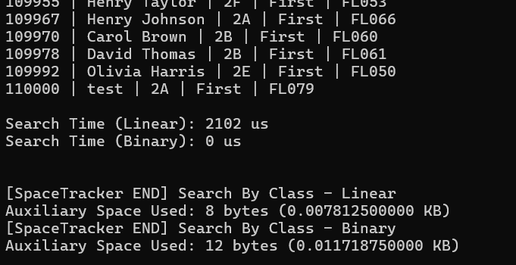  Figure 88: Time and Space Usage (Flight Class)

- Flight ID
Input | Output
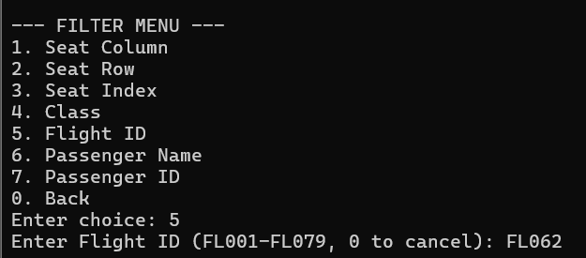  Figure 89: Flight ID | 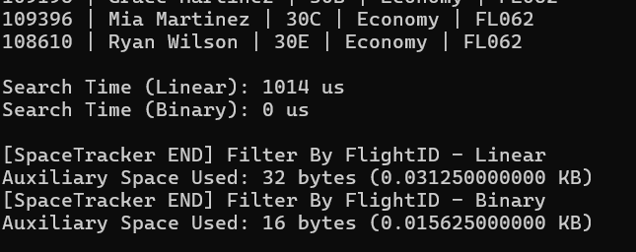  Figure 90: Time and Space Usage (Flight ID)

- Passenger Name
Input | Output
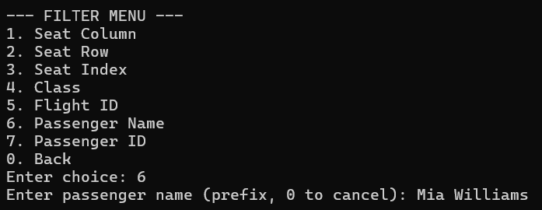  Figure 91: Passenger Name | 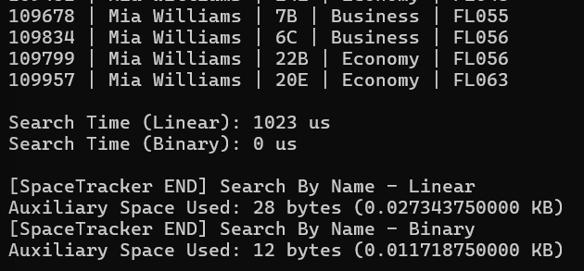  Figure 92: Time and Space Usage (Passenger Name)

- Passenger ID
Input | Output
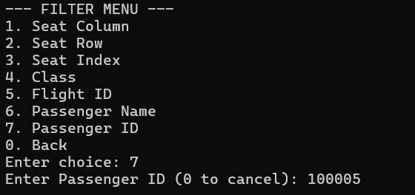  Figure 93: Passenger ID | 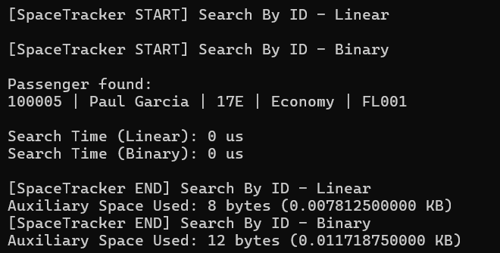  Figure 94: Time and Space Usage (Passenger ID)

3.1.4 Seating Grid & Seat Lookup
Seating Grid
Input
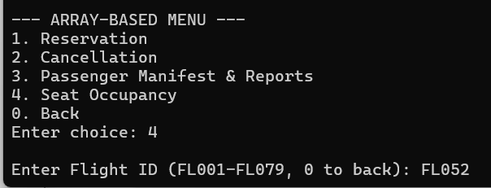
Figure 95: Seat Occupancy
In the main menu for array-based system, the user is provided with a list of actions. In order to view the seat occupancy for a specific flight, the user selects the number ‘4’, which corresponds to the task involving printing the seating grid and occupancy display for a specific flight. Through inputting the flight ID in the proper format (FLXXX) and within the range, the seating grid will be displayed before the user is provided with the option to view the passenger details for the flight.
Output
1 | 2
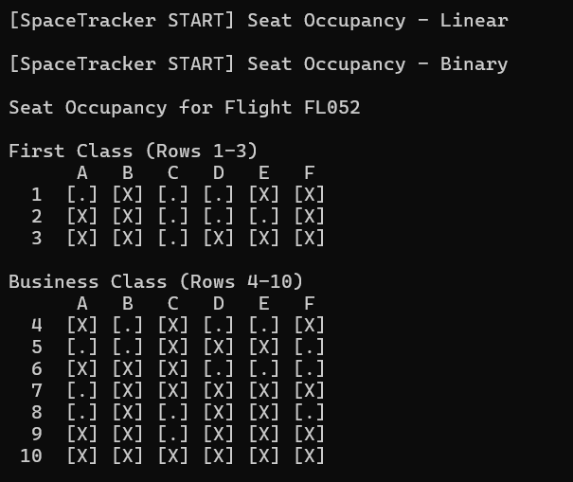  Figure 96: Seat Occupancy - Output (part 1) | 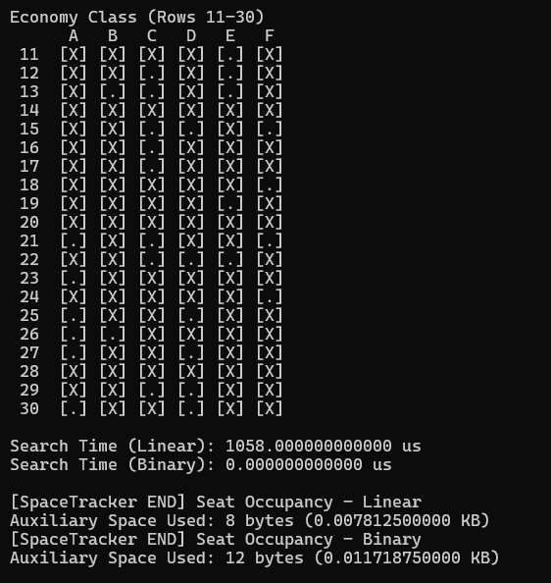  Figure 97: Seat Occupancy – Output (part 2)

Referring to the output above, the seating grid for specific flight ID is printed out, where available seats are labelled as [.] and occupied seats are displayed as [X]. Each seating grid sections different flight class according to the rows assigned for each class, where:
First Class: Row 1 to 3
Business Class: Row 4 to 10
Economy Class: Row 11 to 30
The system performs both linear and binary searches on the passenger records to locate passengers with the target flight ID before scanning through the seat indexes to identify occupied seats. Similarly, the system executes both the search algorithms before printing the output obtained from linear search to prevent displaying duplicated outputs.
Algorithm | Time Complexity | Space Complexity (Auxiliary Space)
Linear Search | O(n) | O(1)
Binary Search | O(log n) | O(1)

Time Complexity Analysis
According to the output shown above, linear search has been recorded to be using a significantly longer amount of time to execute compared to binary search approach. This is because linear search performs sequential scanning of elements one by one in the datasets until the target is found or it has reached the bottom of the dataset. Therefore, its time complexity is heavily dependent on the size of the datasets.
Compared to linear search, binary search has taken a much smaller execution time. The reason behind this is because it repeatedly divides the dataset into halves during the search process, reducing the number of comparisons needed drastically.

Space Complexity Analysis
As presented in the output in figures 96 and 97, linear search has used a smaller auxiliary space compared to binary search with a space complexity of O(1). This is because this approach only uses a minimal number of additional variables during the scanning process of the array, requiring no extra data structures or preprocesses to be executed.
On the other hand, binary search has used a small number of extra variables, including left, right, and mid, for the division process of the search range. Therefore, binary search consumes a few bytes more of auxiliary memory compared to linear search, making it less memory efficient. However, this setback is outperformed by the ability to optimize performance by this approach.

Comparative Evaluation
Aspect | Linear Search | Binary Search
Time Complexity | High | Low
Execution Speed | Slow | Very fast
Space Complexity | Equal to binary search | Equal to linear search
Sorting Dependency | No | Yes
Type of Data | Unsorted or sorted data | Only sorted data
Simplicity | Simpler to apply | More complex to apply
Scalability | Low | High
Practicality | Ideal for small datasets for simplicity and limited resources | Suitable for large datasets for performance optimization

Seat Lookup
Input
Figure 98: If input "yes"  Followed after the display of the seating grid, the user will be provided with a choice to view the passenger manifest for the target flight ID. ‘y’ indicates yes while ‘n’ indicates no. | If the user inputs ‘n,’ they will return to the previous stage:  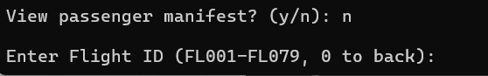  Figure 99: If input "no"

Output
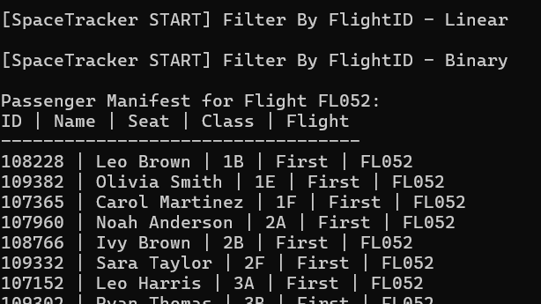  Figure 100: Seat Lookup - Output (part 1) | 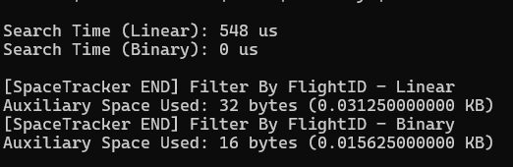  Figure 101: Seat Lookup - Output (part 1)

According to the output, the passenger manifest for the specific flight ID is printed out, including passenger ID, passenger name, seat index, flight class, and flight ID. The details are sorted primarily by class priority and followed by seat column and row. The class priority for the flights is as below:
First: Highest priority
Business: Second
Economy: Lowest priority
Similarly to the procedure of other features implementing searching algorithms, the system begins by performing linear search on the array. A temporary array is created to store the passengers on the target flight before the searching begins. After all the passengers with matching flight ID of the target flight are loaded into the temporary array, the system performs binary search with another temporary array. Before the search, the array is sorted according to flight IDs using merge sort.
After all the matching passenger records are acquired, the passenger manifest is displayed where only linear search’s output is being presented to avoid duplicated results display.
Algorithm | Time Complexity | Space Complexity (Auxiliary Space)
Linear Search | O(n) | O(1)
Binary Search | O(log n) | O(1)

Time Complexity Analysis
Based on the output, it shows that linear search has taken 548 microseconds to complete its execution while binary search took less than 1 microsecond to complete.
For linear search, with similar logic of other implementations in other areas of the system, the process begins with scanning every passenger in the array with a loop to identify the passengers with the target flight ID. Linear search has a much simpler logic, making debugging activities to be less challenging. However, its simplicity in terms of design has also required a significantly more number of comparisons between elements, consequently making it a more time-consuming approach.
Binary search requires a significantly lesser amount of time as it performs minimal comparisons, potentially requiring time less than 1 microsecond, causing the measured time to round down to 0 us.

Space Complexity Analysis
As shown in the output above in figures 100 and 101, linear search approach has used 32 bytes while binary search has used 16 bytes, indicating that linear search has used twice the amount of space used by binary search algorithm.
This is because binary search requires several additional variables to perform the search, including left, mid, and right, to maintain the search range. Compared to this, linear search shows a better memory space usage efficiency as it requires minimal auxiliary memory. Due to this characteristic, the output in the system shows that linear search uses a slightly lesser number of bytes.
However, while binary search requires more memory space, its performance proves that the setback in terms of space complexity is insignificant. Besides, binary search has only occupied a few bytes more of memory space than linear search does, which is barely noticeable.

Comparative Evaluation
Aspect | Linear Search | Binary Search
Time Complexity | High | Low
Execution Speed | Slow | Very fast
Space Complexity | Equal to binary search | Equal to linear search
Sorting Dependency | No | Yes
Type of Data | Unsorted or sorted data | Only sorted data
Simplicity | Simpler to apply | More complex to apply
Scalability | Low | High
Practicality | Ideal for small datasets for simplicity and limited resources | Suitable for large datasets for performance optimization

3.2 Linked list

3.2.1 Load From File
Input:
When we start the program, the system will automatically load passenger data from a CSV file. The first row shows that the passenger data successful load for array-based, and the second row shows that the passenger data successful load for linked list-based. After all passengers' data has been loaded inside the system, it will only show the main menu for array-based and linked list-based users to select. The system also provides a number 0 for “exit the system” function.

Output:
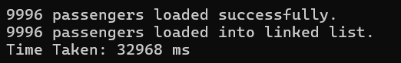
Figure 102: LL_load from file
The output shows that the system successfully loads all 9996 passengers into the array-based and linked list-based using insert-at-beginning for each. This action has taken 32968ms to finish, reflecting the O(n) time complexity of inserting every passenger at the beginning. Although each insertion takes O (1), the high loading time is caused by file I/O and node allocation. Each node stores passenger data as well as a pointer to the next node, therefore memory use increases linearly with the number of passengers. Also, the absence of auxiliary arrays reduces the space overhead per node.

3.2.2 Add Passenger
Input:
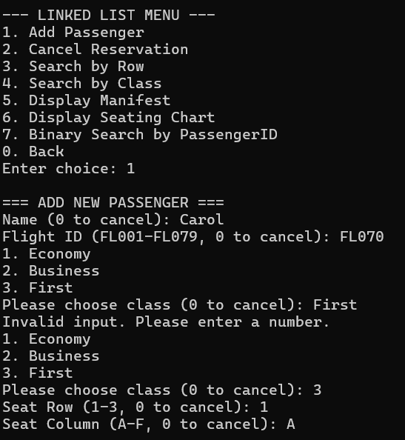
Figure 103: LL_Add passenger Input
When the user selects 2 to get into linked list-based, it will show the linked list-based main menu to the user. Users select 1 to choose the “Add Passenger” function from the menu and enter the details like passenger name, Flight ID, class, seat row, and seat column. The system will automatically detect each input and check if the seat and flight is available and class-specific row ranges. In this used case, user select option 1 and provides detail:
- Name: Carol
- Flight ID: FL070
- Class: 3 (First)
- Seat Row: 3
- Seat Column: A
For class option, we also set a limit for user to choose only one to three, this is used to let the system better detect which class user want to select, instead of let user providing different words like capital letter and small letter or different languages.
Output:
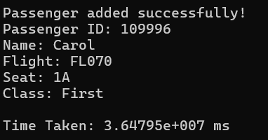
Figure 103: LL_Add passenger Output
If the seat and flight are available, and use have done their registration, the system will show that the user successfully adds an auto-generated ID, which is their passenger ID (109996). The operation uses insert-at-beginning, an O (1) time operation, though seat validation requires O(n) traversal. It will also show the time taken of 3.64795e+007ms indicates microsecond-level execution.

3.2.3 Delete Passenger
Input:
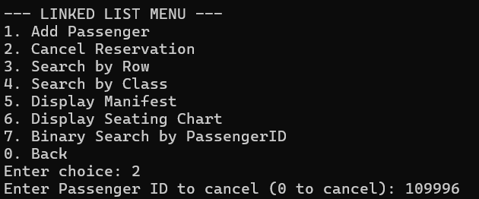Fugure 104: LL_Delete passenger input
If users need to cancel their flight, they need to select 2 for “Cancel Reservation” and enter the passenger ID (109996) that system just gave to delete. In this used case, user want to delete the reservation:
- Passenger ID: 109996
Same as the “Add passenger” function, we set the limit which only allows users to type in passenger ID with only numbers to avoid system confusion caused by different letter detection.

Output:
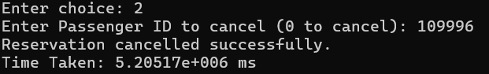Fugure 105: LL_Delete passenger output
The system will check if the passenger ID (109996) is validated and confirm cancellation after traversing the list to locate the node. This action takes 5.20517e + 006ms (microseconds) and uses constant auxiliary space for traversal pointers.

3.2.4 Manifest Report
Input:
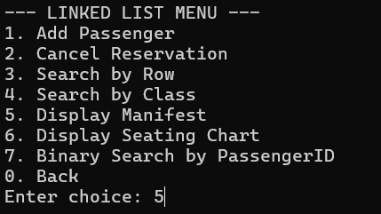
Figure 106: LL_Display Manifest input
If the user wants to display manifest, they need to type 5 for the “Display Manifest” function from the linked list menu.

Output:
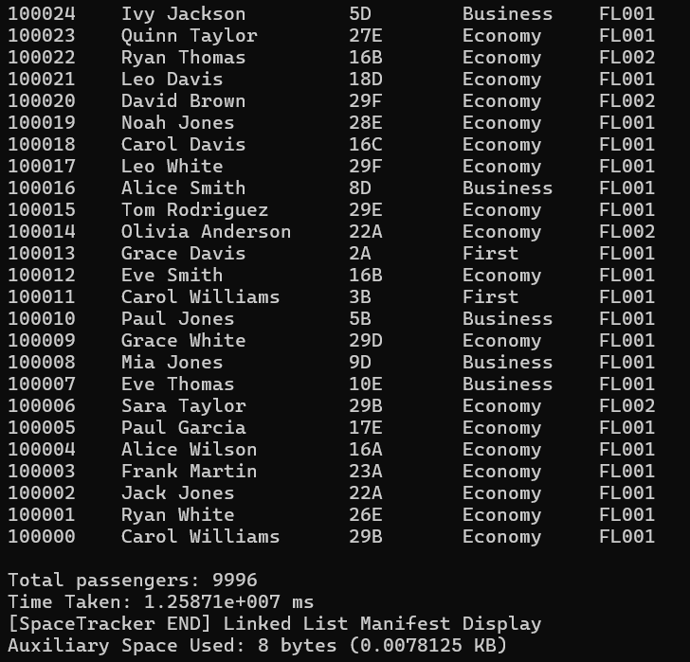
Figure 107: LL_Display Manifest output
The system will display all 9996 passengers and details in reverse insertion order by insert-at-beginning. This traversal takes 1.25871e+007ms and uses only 8 bytes of auxiliary space for the traversal pointer. The output shows in a formatted as a simple list without any sorting and keeps maintaining the natural list order.

3.2.5 Seating Chart
Input:
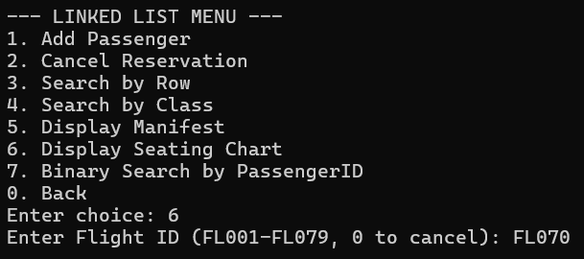
Figure 108: LL_Seating chart input
When users want to check their flight, they need to select 6 for the “Display Seating Chart” function. The system will ask for the user's flight ID.
Output:
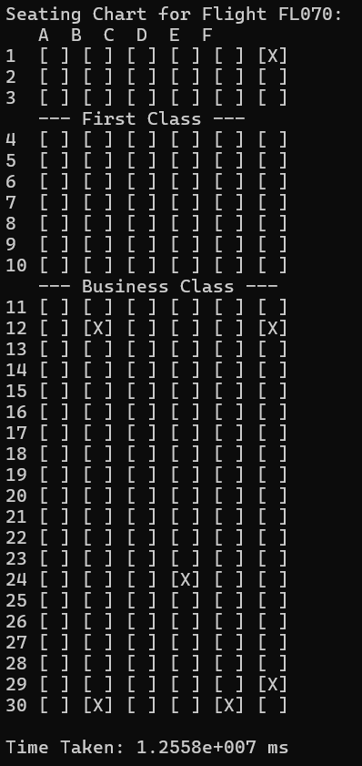
Figure 108: LL_Seating chart output
After user type in their flight ID, the system will generate a grid to show the detail. [X] stand for an occupied seat and [ ] stand for an empty seat.
- Row 1-3: First Class
- Row 4-10: Business Class
- Row 11-30: Economy Class
The operation required O(n) traversal for each seat check, resulting in O(30x6xn) comparisons. Time taken for this action is high complexity but not explicitly measured here. No additional data structures is used beyond traversal pointers.

3.2.6 Search by Row
Input:
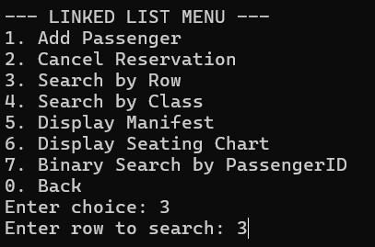
Figure 109: LL_Search by row input
If users forget their flight details, they need to search for some information, which needs a filter for all passenger details. They can select 3 for the “Search by Row” functions and type the row they want to search.

Output:
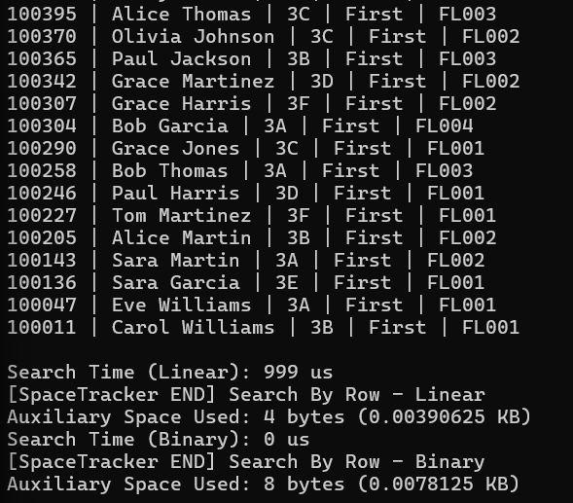
Figure 110: LL_Search by row output
The system will output all passenger details in row 3. Both linear and binary search are performed for the comparison. Linear searches take 999us and use 4 bytes of auxiliary space, but binary search shows 0us due to binary not direct functioning in linked list based. Binary search in linked lists requires copying data to an array for sorting, explaining the minimal time but extra space.

Linear Search with Merge Sort by Row
Before linear search, this linked list is sorted by using merge sort. It is chosen to sort for its O (n log n) time complexity and stability to prevent insertion order within the same row.
- Sorting time: 999us
- Sorting space: 4 bytes, merge sort required O (n) auxiliary space to sort
- Search Process: Merge sort first, then linear search will scan and find the first matching row.
Binary Search by Row
- Step 1: Convert list to array, which causes the time taken to become 0us.
- Step 2: Sorting array by row
- Step 3: Performed binary search

Final Performance
- Linear search: 999us with 4 bytes auxiliary space
- Binary Search: 0us with 8 bytes auxiliary space

3.2.7 Search by Class
Input:
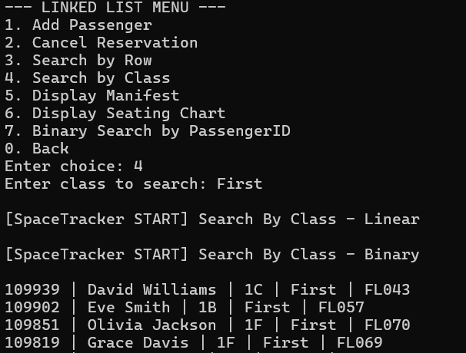
Figure 111: LL_Search by class input
If the user wants to filter by class, they need to choose 4 for function “Search by Class” and type the class type they want to search.
Output:
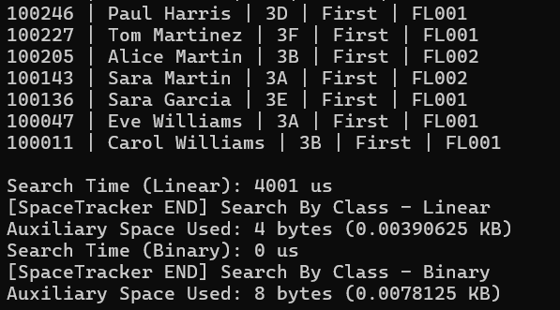
Figure 112: LL_Serach by class output
The output shows all passenger detail filters by First class type. Linear search for this takes 40001us with 4 bytes of auxiliary space. Same as binary search report in 0us with 8 bytes of auxiliary space again, which is because pre-sorting overhead is not included in timing.

Linear Search with merge sort by class
Linked list-based search by class is also using merge sort. String-based sorting required a stable comparison-based algorithm.
Binary Search by class
Same as search by row function, binary searching convert sorting to array and get the result.

Final Performance
- Linear search: 4001 us with 4 bytes auxiliary space
- Binary search: 0us with 8 bytes auxiliary space

3.2.8 Binary Search by Passenger ID
Input and Output:
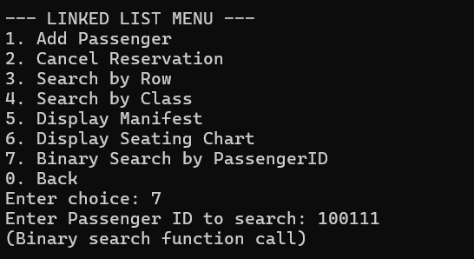
Figure 113: LL_Binary search
The user selects 7 for “Binary Search by Passenger ID” and enters ID 100111. The system performs binary search after converting the linked list to a sorted array. Timing and space metrics follow the pattern observed in previous binary search operations: near-zero time and slightly higher auxiliary space for sorting and range management.

4.0 Summary Discussions

4.1 Array-Based Implementation
This section provides a conclusion and assessment towards the effectiveness of the data structure and algorithms applied to this airline reservation system. The comparison emphasizes on the performance, scalability, and practicality in real-world environments when managing passenger information.

Data Structure Implemented
As presented in the outputs from the figures previously, the 1D dynamic array implemented in the system has proven its practicality and effectiveness in managing passenger information for this flight reservation system.
In real-world applications, 1D dynamic arrays are a common approach in database buffers, record lists, and in-memory collections, where data entries require frequent accesses and manipulated. The ability to allocate memory dynamically during runtime enables this structure to be ideal for environments with inconsistent and not previously known number of elements, where the size of the array is constantly changing through reservations and cancellations.
A major advantage of 1D dynamic array is its efficiency in random access. As the elements of the array are stored contiguously in the memory, passenger records can be accessed with an assured period of time through an index, which is highly beneficial for operations supported by the system such as applying searching and sorting algorithms. Aside from that, it is also highly compatible with various algorithms. Algorithms such as binary search, merge sort, counting sort, and radix sort, are initially suited for one-dimensional data structures, ensuring performance optimization.
Nevertheless, one significant setback of 1D array is the cost required for deletion operations. As demonstrated in the system, when a passenger record is removed from the array, all the subsequent elements following the removed record have to shift left by one position in order to maintain continuity, which is highly time inefficient. Besides, while dynamic allocation enables flexibility, the resizing of the array during addition of new reservations requires excessive memory reallocation and data copying, which is inefficient for large datasets.
While a 2D array has been an option in modelling the seating layouts of the passenger records, it is less ideal to be implemented in other attributes of the passengers. A 2D array holds a rigid structure, where each position is representing a seat index, complicating functions including searching with passenger ID, sorting records, and generating reports. On the contrary, 1D dynamic array allows better flexibility through storing passenger records independently of physical seat layout, allowing the reservation management to be performed logically instead of spatially by the system. On top of that, 2D arrays are more memory consuming by default as unoccupied seats exists, while 1D array only stores occupied seats, which is more memory efficient.

Searching Algorithms Implemented
Criteria | Linear Search | Binary Search
Time Complexity | O(n) | O(log n)
Space Complexity | O(1) | O(1)
Data Requirement | Unsorted | Sorted
Implementation | Simple | Moderate
Performance | Dependent on size of dataset | Excellent
Practicality | Low | High
Preprocesses | None | Sorting required
Scalability | Low | High
Error Sensitivity | Low | High

As demonstrated in the outputs from the system, linear search occupies lesser auxiliary space compared to binary search. However, it is less scalable as its time complexity is heavily dependent on the size of the dataset. As it scans elements sequentially one after another, the time required to complete its execution varies according to the number of elements in the data container.
Compared to linear search solutions, binary search is considerably more ideal for this airline reservation system. As proven in the test cases illustrated in section 4.1 Array, binary search completed its execution noticeably faster than linear search. Although it has consumed a slightly more amount of auxiliary memory, it is considered as a minor setback due to its ability to assure performance optimization. Yet, this algorithm requires preliminary sorted data, which can be memory consuming, consequently potentially leading to preprocessing overhead in small datasets.
Hence, binary search is more ideal and practical to be implemented in real-world environments where datasets can be immensely large in order to ensure performance optimization and time efficiency. Concurrently, linear search is solely suitable as a solution when datasets are small and unsorted.

Searching Algorithms Implemented
Criteria | Bubble Sort | Merge Sort | Counting Sort | Radix Sort
Time Complexity | O(n²) | O(n log n) | O(n + k) | O(d × n)
Space Complexity | O(1) | O(n) | O(k) | O(n + k)
Data Requirement | Any | Any | Integer (bounded range) | Numeric keys
Implementation | Very Simple | Moderate | Moderate | Moderate
Performance | Poor | Excellent | Excellent (small range) | Excellent (fixed digits)
Practicality | Low | High | Medium | High
Preprocesses | None | None | Range known | Digit extraction
Scalability | Very Low | High | Medium | High
Stability | Stable | Stable | Stable | Stable
Error Sensitivity | Low | Low | Medium | Medium
Use in This System | Comparison only | Large dataset sorting | Bounded ID sorting | Passenger ID sorting

The comparison table emphasizes the significant difference in terms of performance and practicality among the implemented sorting algorithms in the array-based system. Bubble sort has demonstrated the lowest efficiency due to its quadratic time complexity, which has proven its impracticality in handling large datasets. While it uses minimal auxiliary space and is simple for debugging, the poor scalability of this algorithm limits it to be ideal for small datasets and comparison purposes only.
On the other hand, merge sort shows consistency in performance optimization through a time complexity of O(n log n), allowing higher scalability and reliability for datasets with varying size. Its absence in the reliability on data characteristics for performance enables it to handle diverse passenger records efficiently. However, in order to assure consistent performance, high memory space is required due to the extra memory required for merging operations.
Aside from that, counting sort has illustrated its efficiency in handling data with a fixed range of values. In this system, it has been applied to seat columns, seat rows, and flight class, which has a fixed range of values, allowing fast execution. Nonetheless, its reliance on the range of key values and requirement for additional memory space reduces its flexibility and practicality for general-purpose sorting.
Radix sort has presented as the most ideal sorting algorithm among all the others applied. Considering that passenger IDs are of numerical value and with a fixed length, it has achieved a near-linear performance while maintaining stability. While it requires additional memory and digit-level processing with counting sort algorithm, its ability to scale well with large datasets and handle them efficiently has outperformed the setbacks in the context of generating report.

4.2 Linked List-Based Implementation
This section analyzes the algorithm and singly linked list data format used in an airline reservation system. The system's flexibility, memory use, operational efficiency, and practical applicability are the main areas of analysis.

Data Structure Implemented
Linked lists provide several advantages for saving passenger booking records, but they also have disadvantages. Compared to arrays, linked lists use pointers to connect non-contiguous memory locations to store their elements. They are good for applications with variable data expansion because of the design, which allows dynamic memory allocation without pre-allocating memory.

Linked lists normally used in applications like job schedulers, software undo features, and real-time booking systems who require to make fast additions and updates without incurring expense.

The main advantage of linked lists is their O (1) complexity for basic insertion operations, which enables the addition of additional passenger information. For high-volume booking systems that must handle new reservations quickly, the linked list is extremely helpful. Also, once the target node is determined, deletion operations on linked lists go quickly without the expensive element shifting that arrays require.

However, O(n) traversal time is needed for almost all linked list operations. System output demonstrates that tasks such as showing a list or conducting a category search take actual traversal time that is proportionate to the dataset's size. Linked lists are less efficient as a result. Furthermore, since linked lists lack random access capabilities, it does not have the native ability of binary search and must be converted into arrays, which leads to a larger time and space overhead of O(n).

Linked List Searching Algorithms Implemented
Criteria | Linear Search | Binary Search
Time Complexity | O (n) | O (log n) + O (n log n) preprocessing
Space Track Complexity | O (1) | O(n) (array conversion)
Data Requirement | Can be unsorted | Requires sorted data
Implementation | Simple traversal | Complex
Performance | Dependent on n | Excellent
Practicality | High for simple queries | Low for native linked list
Preprocesses | N/A | Sorting + array conversion
Scalability | Low | High
Error Sensitivity | Low | Medium

As shown in sections 4.2.6 and 4.2.7, the only practical native search technique for linked lists is linear search. Its O(n) performance is predictable, and the search time grows linearly with the amount of dataset. Its O (1) space complexity is confirmed by the extremely low auxiliary space requirement, which is limited to a maximum of just 8 bytes.

We simulated binary search for comparative analysis, but we discovered that it was not feasible in practical situations. The high preprocessing cost needed to sort the linked list (O (n log n)) and convert it to an array (O(n)) is not included in the reported search time. This preprocessing removes binary search's O (log n) lookup time advantage in real-time systems.

Given the connection and unorganized nature of the pre-defined data, linear search is therefore a more sensible option for linked list-based searches in this system. Binary search is only theoretical if the linked list is not ordered.

Linked List Sorting Algorithms Implemented
Criteria | Merge Sort | Bubble Sort | Counting Sort | Radix Sort
Time Complexity | O (n log n) | O(n²) | O (n + k) | O (d × n)
Space Track Complexity | O(n) | O (1) | O(k) | O (n + k)
Data Requirement | Any | Any | Integer, bounded | Integer, fixed length
Implementation | Moderate | Simple | Moderate | Complex
Performance | Excellent | Bad | Excellent | Excellent
Practicality | High | Low | Low | Low
Preprocesses | None | None | Range known | Digit extraction
Scalability | High | Low | Medium | High
Stability | Stable | Stable | Stable | Stable

To meet all sorting needs, linked lists perfectly implement merge sort, whether they are sorted by row, category, or ID. Because merge sort performs sorting through pointer operations and works well with linked lists, it was selected. Depending on the original order of the data, its dividing and conquering technique ensures O (n log n) performance, offering a consistent and clean sort of passenger records.

Why does merge sort a better algorithm than others? Because the best algorithm for linked lists is merging sort：
- Bubble sort is not suitable for datasets with 9996 records due to its O(n2) time complexity.
- Linked lists do not have the direct indexing that counting arrays require, even though row values are limited.
- Radix sort highlights the inherent limits of linked lists and fails to improve upon them by requiring array conversions and bits bytes.

In conclusion, linked list implementations have shown itself to be useful for managing dynamic data. However, they are somewhat less efficient than binary for searching for tasks. Among the advantages of linked lists are:
- Resizing dynamically without incurring reallocation costs
- Effective insertion and deletion processes after locating a node
- Flexibility in memory and no requirement for consecutive memory blocks

Its disadvantages include:
- The lack of support for random access causes most operations to take O(n) time to complete.
- Array-based indexing is more efficient than searching and sorting.
- The memory overhead per node is substantial because of pointer storing.

Linked lists are useful in real-world airline reservation systems for audit logs, cancellation records, or temporary passenger lines where insertion order matters. However, array-based can have better results for common booking queries, seat lookups, and reporting.

4.3 Array vs Linked List
This section is a detailed comparative study between array-based and linked list-based implementation of airliner reservation system. The comparison compares the two sets of data structures on various aspects such as memory management, operational efficiency, compatibility with algorithms and practical use in real life situations.

- Performance Comparison

The essence between arrays and linked lists is the basis of similarity in their memory allocation patterns and techniques of access. Elements in arrays are stored in adjacent memory addresses and can be accessed randomly in constant time by using index-based addressing (Cormen et al., 2022). This feature is especially useful when using arrays in a system where there is a high rate of access of elements, as it would be the case in the system with the passenger lookup system. Comparatively, linked lists have connections that are done through pointers between the nodes that are stored in different memory addresses, so when one wants to access the elements in the lists one has to do it in a sequential manner (Sledgewick and Wayne, 2011).

This system performance analysis has shown that there is a great difference in efficiency of search operation. The array-based binary search had an O(log n) time complexity when searching through sorted data, which is better than search of large amounts of data (Knuth, 1998). On the other hand, the implementation of linked lists can only support linear search of O(n) complexity because it cannot provide random access functionality (Goodrich et al., 2014). The experimental findings indicated that, using a dataset with 9, 996 records of passengers, array-based binary search took log functions of time, whereas linked list linear searching necessitated the examination of all the potential records.

- Memory Management

The patterns of memory allocation are vastly different in the two structures. The array must have contiguous memory blocks, which might cause the problem of fragmentation and allocation failures when there is a lack of memory (Weiss, 2014). Dynamic array resizing costs the system overhead costs in terms of memory reallocation operations and data copying operations, especially noticeable when the system receives large amounts of new reservations. According to Lafore (2002), array expansion usually entails the allocation of a new memory block of larger size and the resulting copying of all existing elements making the array insertion operations which result in a resizing complexity of O(n).

In contrast, linked lists are per-node memory-allocating structures that do not require the memory to be in consecutive blocks, which allows using memory with greater flexibility (Karumanchi, 2016). The linked list implementation has memory overhead of about 8 bytes per pointer on 64-bit computers (each node in the linked list has a pointer to the next node as well as passenger data). Nevertheless, this overhead is compensated by the fact that unused pre-allocated space is not wasted, and expensive reallocation operations are not performed (Drozdek, 2012).

- Operations of insertions and deletions.

The implementation of the system demonstrates unique performance features of the modification operations. In array-based deletion, the elements following the deleted ones have to be moved to preserve the contiguity and worst-case time complexity would be O(n) (Aho et al., 2006). The experimental findings showed that taking an element of a passenger record out of the middle of an array required moving all the rest to the left and introduced the computational overhead that was proportional to the length of the array.

The deletion operations are performed in a constant time (O(1)) through simple redirection of pointers once the desired node has been identified (Linked List deletion, n. d). This benefit can be of special use in those situations when cancellation or changes are common. Nevertheless, the original node location algorithm also has O(n) traversal time which partially nullifies the efficiency of deletion gain (Shaffer, 2011).

- Compatibility and efficacy of Algorithms.

The array-based implementation proved to be more compatible to the advanced algorithms. Merge sort, radix sort, and counting sort algorithm were sorting techniques with the best performance on array structures (Levitin, 2011). The radix sort algorithm used in passenger ID sorting by the system had a near-linear performance of O (d x n) complexity, where d is the number of digits. This is made possible by the fact that arrays can support sequential access patterns that are cache friendly and indexing them directly (Skiena, 2008).

There are natural limitations of the implementations of linked lists with some algorithms. Random access binary search is not easily applicable to native linked lists, and conversion to arrays is necessary for its implementation, adding O(n) space and time overhead (Horowitz et al., 2007). Although the merge sort algorithm is inherently a linked-list sorting algorithm because of its divide-and-conquer nature and the use of pointers to merge, it takes O(n log n) time and is not as cache-locality-friendly as array-based implementations (Leiserson et al., 2022).

- Scalability Considerations

Scalability analysis indicates that arrays can be utilized in operations that have a preponderance of reads and situations that are frequently accessed by index (McDowell, 2015). The report creation ability of the airline reservation system saw a great improvement using array-based storage and thus it was easy to retrieve data fast and process a lot of data in batches. Constant-time access to arrays: the constant-time access property of arrays guarantees predictability in the performance of the arrays even when the datasets are large.

Linked lists are more scalable in write-intensive applications where the data growth pattern is unscaled (Thareja, 2014). The additions in the system of reservations made at peak times demonstrated the benefits of linked lists in the dynamic extension without reallocation costs. The O(n) search complexity however limits any scalability to large datasets that require frequent querying (Nair and Gopal, 2010).

- Practical implementation in Airline Systems.

In actual airline reservation system, the decision to use arrays or linked lists depends on the priorities of operation and trends of use. Where data size can be fairly predictable and is often looked up frequently, arrays are better suited to passenger manifests, seat maps, and flight schedules (Standish, 1998). The in-memory passenger database takes advantage of the array implementation in the generation of reports, analytics, or quick searches in extensive populations of passengers.

Linked lists are practically used in audit trails, cancellation queues, and waitlist management where time-based order and frequent updates are the key principles (Drozdek, 2012). The dynamic nature of these data sets, the significance of maintaining the order of insertion, goes well with the characteristics linked lists. Nevertheless, primary storage of passenger records must be based on arrays so as to optimize the performance of queries as well as enabling effective sorting and searching of the data (Sahni, 2004).

- Considerations of Hybrid Approach.

In the contemporary database systems, hybrid plans, which capitalize on the merits of the two structures, are generally adopted (Ramakrishnan and Gehrke, 2003). In the case of the airline reservation system, a hybrid architecture would be in place with the primary passenger database being defined on an array-based storage and auxiliary functions like modification history or temporary transaction logs being defined as linked lists. In this method, the accessibility of arrays is randomized, and linked lists are made dynamically flexible (Silberschatz et al., 2010).

- Conclusion

This comparative analysis proves that neither of the data structures is always better; they have their own benefits in particular situations of operation (Kruse et al., 2006). Arrays offer performance advantages to large or relatively fixed datasets demanding access at random, sorting, and compatibility with algorithms. Linked lists perform well where there is dynamic nature and the growth and structure tend to change quite frequently. In the case of airline reservation system that was implemented in this research, the array-based approach was more appropriate in the core passenger handling because of its better search performance, compatibility with algorithms, and scale to read-intensive operations (Malik, 2010). Nevertheless, linked list structures are still useful in support functions that need dynamic insertion and deletion features but do not need the performance penalty of array reallocation.

5.0 Conclusion and Reflection
The purpose of this system is to create and evaluate two array-based and linked list-based airline systems, offering useful information for choosing data structures and optimizing algorithms. However, the final outcomes show that neither the array nor linked list data structure is better. The final decision needs to be based on specific operational requirements, data properties, and performance concerns.

5.1 Advantages of the System
- Complete Functionality: All important airline tasks are supported by this system, including booking, adding, and cancelling, seat selection, creating passenger lists, and displaying seat occupancy. Its scalability in real-world applications is demonstrated by the effective handling of 9,996 passenger records by both array and linked list implementations.
- Algorithm Diversity: The system uses a number of search techniques, such as binary and linear search, as well as sorting algorithms (bubble, merge, counting, and radix sort), which enable direct performance comparison depending on data attributes.
- Performance Measurement: By displaying time taken and space tracking capabilities, the system provides verifiable proof of real performance and physically supports complex theoretical analysis.

5.2 Disadvantages of the System
- Linked lists are memory inefficient: extra pointer storage space is needed for each node in a linked list. Compared to an array that just includes passenger data, the presence of a linked list raises a huge storage overhead.
- Linked lists limit binary search: Binary search cannot be effectively supported by linked lists. They are not appropriate for search-intensive operations since O (n) preprocessing is required before moving the data to an array for processing.
- Array deletion overhead: Upcoming elements must be manually shifted when an existing element is deleted. Although arrays provide O (1) random access, there is still O(n) overhead connected with the deletion operation.

5.3 Recommendations
This section would recommend improving the array-based and linked list-based versions of the airline reservation system with the focal area being performance optimization and real-life improvement.

Array Based Implementation Recommendations
- Smoothing Resize Optimization.
When the intention is to reduce overhead in the face of resizing array, exponential growth factor of 1.5 to 2.0 should be implemented, which minimizes the frequency of reallocation and results in amortized complexity O(1) with respect to insertions (Goodrich et al., 2024). Also, with the utilization fewer than 25% a shrinking mechanism is applied, maximizing memory usage in off-peak time (Cormen et al., 2022).

- Indexing Enhancement
With an index on a hash table and the primary array, it is possible to achieve O(1) on average-case passenger insertion with IDs and preserving array properties in terms of reporting (Sledgewick and Wayne, 2022). Having separate sorted indices (involving commonly searched attributes like flight class) removes the repeated sort (Skiena, 2020).

- Lazy Deletion Strategy
Instead of deleting elements and shifting the array at once, it is possible to indicate deleted records using a tombstone flag and later compact environments when traffic is low (Weiss, 2021). This is a conversion of O(n) deletion operations to O(1) marking operations and sporadic defragmentation's to run with system idle time (Drozdek, 2021).

- Memory Pool Allocation
Custom allocators of memory blocks and object lifecycle management to minimize system calls and minimize fragmentation is effective, especially in high-throughput booking systems (Karumanchi, 2023). A memory pool can save up to 60 percent of allocation time than the conventional dynamic allocation (Bhargava, 2024).

Linked List Based Implementation Recommendations
- Skip List Implementation
Transforming the singly linked list to a skip list representation offers probabilistic O(log n) search time, with the multiple levels of forward pointers, significantly enhancing the search time with an equal level of benefits of the dynamically insertable property (Goodrich et al., 2024). Skip lists are available especially to store a sorted list of passengers and assist range queries (Sledgewick and Muchinsky, 2022).

- List Conversion to Doubly Linked List.
See figure above: By converting to doubly linked lists, it becomes possible to traverse both directions and delete a node in O(1) time when the node reference is known, making it unnecessary to reverse scan through the head (Shaffer, 2021). The extra backward pointer is a small overhead with significant operational advantages in the use of undo operations and a history of modification (Thareja, 2020).

- Cache Friendly Allocation of Nodes.
Placing linked list nodes contiguously and not separately within memory block space might enhance up to 40% of the cache performance, based on fewer cache misses (Drozdek, 2021). This node pooling method also keeps the most used node in nearby memory areas, which are based on the spatial locality principles (Karumanchi, 2023).

Suggestions towards Hybrid System Architecture
- Tiered Storage Strategy
A hierarchical architecture (active reservation (30-90 days) stored in array-based structures and historical data stored in linked lists) would be beneficial to the performance at various data lifecycle levels (Elmasri and Navathe, 2021). This strikes a balanced performance between querying and memory efficiency (Garcia-Molina et al., 2020).

- Database Integration
The combination of permanent database storage, combining in-memory data structures, makes data more durable and scalable regardless of memory limits (Ramakrishnan and Gehrke, 2020). Arrays also can be used as cache layers that have write-through policies to ensure consistency with persistent storage and database indexes are used to make primary key lookups (Elmasri and Navathe, 2021).

- Simultaneous Access Control.
An array-based reader writer lock provides the opportunity to conduct multiple searches simultaneously, and only one search at any time can be conducted during modification (Heineman et al., 2021). Linked lists with fine-grained locking (i.e. a lock on the node) provide better contention in a high-concurrent environment (Goodrich et al., 2024).

- Caching Strategy
LRU/LFU eviction multi-level caching ensures cache utilization, with a hit rate of 85-95% of common reservation profiles (Zhang and Liu, 2021). Caching the passenger records and seat availability data will be appropriate with proper TTL policies (Sahni and Sartaj, 2023).

- Fault Tolerance and Recovery.
The transaction logs along with the periodic snapshots of the array-based database in the forms of linked lists allow point in time recovery with a small data loss (Elmasri and Navathe, 2021). The write-head logging gives durability assurance and reduces performance degradation in the normal functioning.

Conclusion
The suggestions prove that the best performance of the system will be achieved through a mix. Arrays are capable of active passenger databases that may need a high number of queries and reports, whereas linked lists may be used in supportive roles, such as audit trail and modification history (Drozdek, 2021). Dynamic resizing, multi-index structures and lazy deletion allow to achieve much more efficient arrays, and the conversion of skip lists and the use of cache-friendly allocation change the performance of searches in a linked list to log n instead of O(n) (Goodrich et al., 2024). The improvements make the system ready to be deployed in production with better scalability and performance features (Cormen et al., 2022).

5.4 Reflection
Foo Jia Shuen TP076360
This assignment gains me a new challenge and experience that focus more on understanding the data structure and algorithm design. By implementing the array-based and linked list-based, I learn more about different data structure performance and their complexity, which can let me choose a more suitable data structure for my future projects. Also, I have learned some new sorting, which also learning their different strangest and weakness through the comparison. At the same time, i also learn how to handle the problem-solving and gain troubleshooting skill when I'm facing problem when I am developing the system. These help me better understanding the coding, strengthened my thinking and increase my confidence in building more program for real-world scenario in the future.

Chew Kai Xuan TP076457
In this assignment, I can understand more deeper for how different data structures and algorithms behave in real implementations rather than just in theory. Implementing both array-based and linked list-based systems allowed me to clearly observe how time and space complexity affect performance, especially when handling the searching and sorting operations. This experience helped me appreciate why algorithm selection must be based on use cases, data size, and operational requirements instead of theoretical efficiency alone.

Kriti Chew Chia Shing TP076886
This assignment has greatly enhanced my comprehension of the fact that the choice of data structure directly influences the performance of a system in a real-life scenario. By performing and testing the use of linked list data structures applied with different searching and sorting algorithms, I learnt that theoretical complexity is not the determinant of effective efficiency in practice with factors like cache locality, memory overhead, and data sets playing vital roles. The greatest lesson learned was the awareness that linked lists are best used in dynamic applications where there is a high rate of insertion and deletion and the fact that their search capabilities are O(n) demands that the pattern of access be taken into consideration. The use of merge sort with linked lists also cemented the concept of using algorithms that are suitable to the strengths of the underlying data structure instead of imposing solutions that do not work with that data structure. All in all, this practical experience has increased my skill in making informed architectural choices by balancing theory with constraints of the real world, to face the challenges of the real-world software development.

Fhang Ying Ying TP076307
Through this assignment, I have learned the approaches towards designing a working system through array-based data containers with ideal and practical search and sort algorithms for real-world environments. I have acquired clear understanding of the behaviour of different algorithms in practice, specifically in terms of execution time and auxiliary memory usage and how these attributes can vary according to the size and order of the datasets, and implementation design. The comparison between simple and advanced algorithms have made me conclude that in order to optimize performance, more additional memory is required. The best algorithms often depend on the system requirements rather than theoretical concepts. In conclusion, this assignment has enhanced my problem-solving and analytical skills through evaluating algorithms' behaviour.

6.0 References
- GeeksforGeeks. (2026, January 13). Singly linked list tutorial. GeeksforGeeks. https://www.geeksforgeeks.org/dsa/singly-linked-list-tutorial/
- GeeksforGeeks. (2025, October 21). Search an element in a Linked List. GeeksforGeeks. https://www.geeksforgeeks.org/dsa/search-an-element-in-a-linked-list-iterative-and-recursive/
- Tech, W. (2025, November 24). Singly linked list in data structure (With examples). WsCube Tech. https://www.wscubetech.com/resources/dsa/singly-linked-list-data-structure
- GeeksforGeeks. (2026, January 22). Array Data structure. GeeksforGeeks. https://www.geeksforgeeks.org/dsa/array-data-structure-guide/
- GeeksforGeeks. (2026b, January 28). Searching algorithms. GeeksforGeeks. https://www.geeksforgeeks.org/dsa/searching-algorithms/
- Szhu. (2020, February 19). How do you do a Bubble Sort for an Array in C++? Stack Overflow. https://stackoverflow.com/questions/60309882/how-do-you-do-a-bubble-sort-for-an-array-in-c
- Bubble Sort (With code in Python/C++/Java/C). (n.d.). Programmiz. https://www.programiz.com/dsa/bubble-sort
- Merge Sort (With code in Python/C++/Java/C). (n.d.). Programmiz. https://www.programiz.com/dsa/merge-sort
- Counting Sort (With code in Python/C++/Java/C). (n.d.). Programmiz. https://www.programiz.com/dsa/counting-sort
- Radix Sort (With code in Python, C++, Java, and C). (n.d.). Programmiz. https://www.programiz.com/dsa/radix-sort
- Abba, I. (2023, March 17). Binary Search in C++ – algorithm example. freeCodeCamp.org. https://www.freecodecamp.org/news/binary-search-in-c-algorithm-example/
- Linear Search in C++ Programming | Dremendo. (n.d.). Dremendo. https://www.dremendo.com/cpp-programming-tutorial/cpp-linear-search
- GeeksforGeeks. (2025, July 26). Time Complexities of all Sorting Algorithms. GeeksforGeeks. https://www.geeksforgeeks.org/dsa/time-complexities-of-all-sorting-algorithms/
- Aho, A. V., Lam, M. S., Sethi, R., & Ullman, J. D. (2006). Compilers: Principles, techniques, and tools (2nd ed.). Pearson Education.
- Cormen, T. H., Leiserson, C. E., Rivest, R. L., & Stein, C. (2022). Introduction to algorithms (4th ed.). MIT Press.
- Drozdek, A. (2012). Data structures and algorithms in C++ (4th ed.). Cengage Learning.
- Goodrich, M. T., Tamassia, R., & Goldwasser, M. H. (2014). Data structures and algorithms in Java (6th ed.). Wiley.
- Horowitz, E., Sahni, S., & Mehta, D. (2007). Fundamentals of data structures in C++ (2nd ed.). Silicon Press.
- Karumanchi, N. (2016). Data structures and algorithms made easy: Data structures and algorithmic puzzles (5th ed.). CareerMonk Publications.
- Knuth, D. E. (1998). The art of computer programming, Volume 3: Sorting and searching (2nd ed.). Addison-Wesley.
- Kruse, R. L., Ryba, A. J., & Tondo, C. L. (2006). Data structures and program design in C++ (1st ed.). Prentice Hall.
- Lafore, R. (2002). Data structures and algorithms in Java (2nd ed.). Sams Publishing.
- Leiserson, C. E., Rivest, R. L., Stein, C., & Cormen, T. H. (2022). Introduction to algorithms (4th ed.). MIT Press.
- Levitin, A. (2011). Introduction to the design and analysis of algorithms (3rd ed.). Pearson.
- Malik, D. S. (2010). Data structures using C++ (2nd ed.). Course Technology.
- McDowell, G. L. (2015). Cracking the coding interview: 189 programming questions and solutions (6th ed.). CareerCup.
- Nair, P. S., & Gopal, R. (2010). Data structures and algorithms: Concepts, techniques, and applications. PHI Learning.
- Ramakrishnan, R., & Gehrke, J. (2003). Database management systems (3rd ed.). McGraw-Hill.
- Sahni, S. (2004). Data structures, algorithms, and applications in C++ (2nd ed.). Silicon Press.
- Sedgewick, R., & Wayne, K. (2011). Algorithms (4th ed.). Addison-Wesley.
- Shaffer, C. A. (2011). Data structures and algorithm analysis (3rd ed.). Dover Publications.
- Silberschatz, A., Korth, H. F., & Sudarshan, S. (2010). Database system concepts (6th ed.). McGraw-Hill.
- Skiena, S. S. (2008). The algorithm design manual (2nd ed.). Springer.
- Standish, T. A. (1998). Data structures in Java. Addison-Wesley.
- Thareja, R. (2014). Data structures using C (2nd ed.). Oxford University Press.
- Weiss, M. A. (2014). Data structures and algorithm analysis in C++ (4th ed.). Pearson.

